CASE STUDY
PROJECT: Green Bus Shelters - Freeman Hospital
LOCATION: Newcastle
CLIENT: Newcastle Hospitals NHS Foundation Trust
CONTRACTOR: Autocross Euroshel
PRODUCT/SERVICES SUPPLIED: Mirror Polished 316L Stainless Steel Brilliance Plus Shelters with Sedum Green Roof Systems.

LIVING ROOF BUS SHELTERS HELP TO OFFSET THE URBAN HEAT ISLAND.

Background:

Most people by now are fully aware of the effects of global warming, especially within our cities. The increased emissions from traffic and industry are rapidly toxifying our air, not to the point where it noticeably poisonous to us, but to where the air quality falls some way short of the safe guidelines in many cities.

With this added air pollution comes the result of heat soak, when all the hard concrete and glass surfaces within a city both reflect and absorb heat. This is known as the Urban Heat Island, which can raise urban temperatures by around 7° centigrade. So, anything we can do to help absorb these airborne toxins, or to cool our urban environment, no matter how small, has got to be worthwhile.

Green roofs not only absorb carbon but help to capture contaminant particles. In return they give back clean air. As well as air filtration they also help to attenuate water, slowing down and taking up some of the storm water before it disappears down our sewer systems. They give a lot of this water back to the atmosphere via evapotranspiration, all helping to offset the effects of the Urban Heat Island.

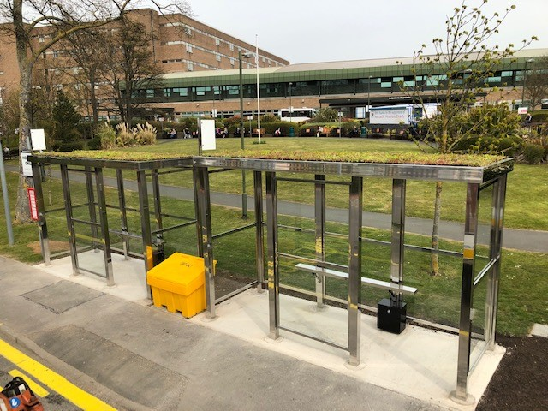

With green space in short supply in most cities, Utrecht in the Netherlands pioneered using otherwise unused space on top of bus shelters for added biodiversity. By 2019 they already had over 300 bus shelters featuring green roofs, not only encouraging, bees and insects and other pollinators, but also helping to soak up storm water.

The brief:

Here in the UK, Autocross Euroshel has been a family business for fifty years, producing shelters for use across the UK. The latest editions feature high grade 316L Mirror polished stainless steel, so they look fantastic as well as serving as valuable shelter from the elements.

They were approached earlier this year to produce two bus shelters to be situated outside the Freeman Hospital in Newcastle-upon-Tyne. The brief was to not only provide aesthetically pleasing shelters that would stand the test of time, but also to incorporate a green roof on each. The simplest solution was to use ready-made cassettes containing everything necessary to establish a successful sedum green roof.

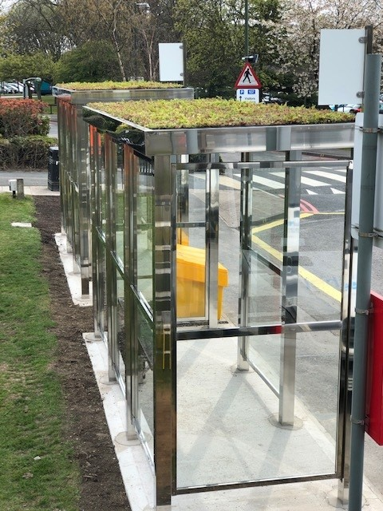

The shelters were strengthened to take the weight of the green roof, and the sedum cassettes were situated within a custom-made Roof panel, sloped slightly to allow any excess water to drain off via an outlet pipe concealed within the rear stanchions. This water then drains away into a land drain.

Green-tech involvement:

Euroshel approached Green-tech to supply their sedum cassettes. Each cassette contains four key layers. At the base is a drainage layer of expanded clay granules, which slows water filtration without water-logging, as well as holding on to some moisture within its micro-pores. Above this sits a filter layer; a geo-textile that allows the passage of water, but not any substrate particles which could block the drainage holes. Then sits the substrate itself, which has been specially blended to meet the needs of the sedum, offering nutrients, moisture, and anchorage to the plants above. Finally, the sedum itself. Each cassette offers near 100% coverage, which gives instant impact once the cassettes are laid.

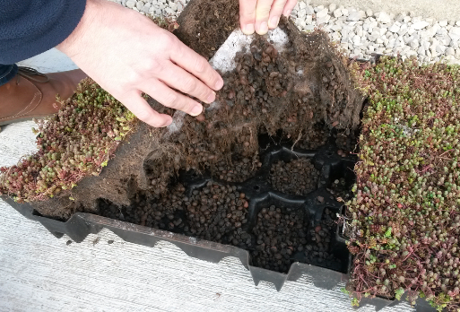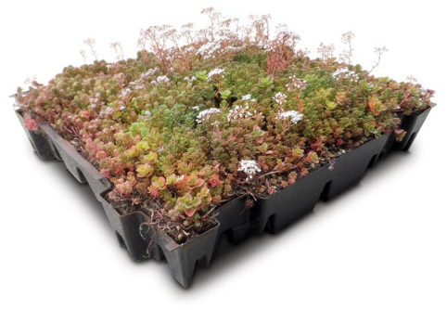

Measuring just under half a metre square, each cassette connects to the adjoining unit, making installation both simple and extremely quick. Once laid, apart from light maintenance each autumn and spring to remove any weeds or dead foliage, and check that the drainage holes are clear, they really are a “lay it and leave” solution to add more green to our urban commuter routes.

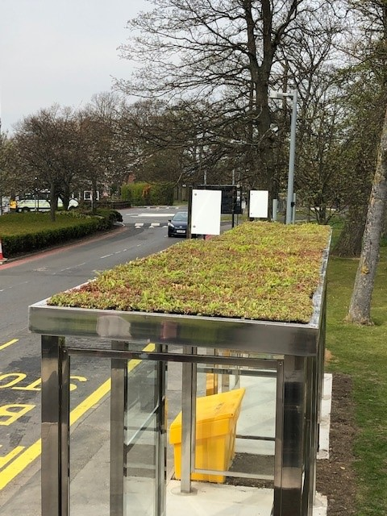

Phil Smith – Operations Manager – Autocross Euroshel
Green roofs highlight the value of integrating sustainable design and green travel in attempts to reduce rates of climate change. We were delighted with Green-tech’s sedum cassettes. They were lightweight, which obviously helps when working at height to install. I hope to be able to use Green-techs services for further living roof bus shelters.

Alasdair Innes – Green-tech Specification Advisor:
It was great to be able to work with Euroshel on their Green roof bus shelters. We often extol the virtues of using sedum cassettes as a quick, easy, and cost-effective way of creating smaller green-roofs, and to see them being used out in the public arena like this is a sure fire indicator that public bodies are really starting to explore more ways to improve our green infrastructure.

