ENVIRONMENT COMMITTEE FINANCE REPORT UP TO 31.05.2023

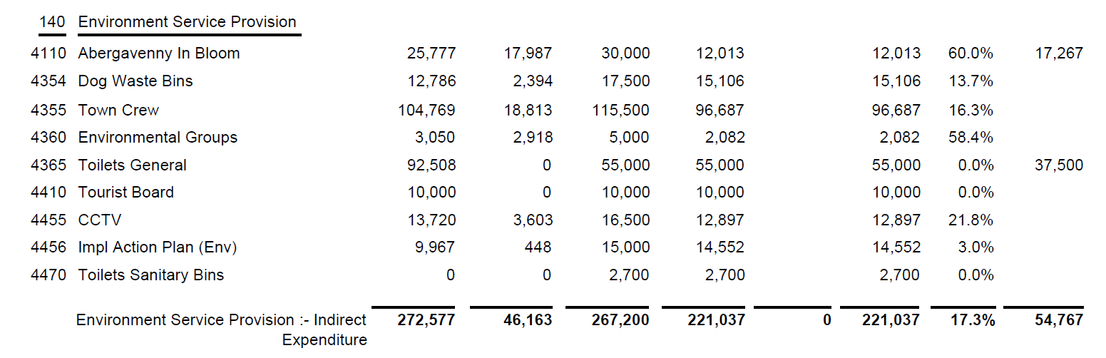

SIGNED AND CONFIRMED AS A TRUE RECORD AS PER AGENDA ITEM E75/23.

CHAIR………………………………………………………

DATE ……………………………………………………...

