ABERGAVENNY TOWN COUNCIL
ENVIRONMENT COMMITTEE
WEDNESDAY 26TH JULY 2023
E 84/23: COMMUNITY NATURE SPACES CONSULTATION
Monmouthshire County Council has been awarded ‘Local Places for Nature’ funding by Welsh Government to build upon the success of the Community Nature Spaces schemes in Monmouth and Chepstow to deliver a similar scheme in Abergavenny.
The project, which is currently in its initial phase, is seeking the opinion of local residents about the proposed sites in Abergavenny and their potential uses via a short questionnaire on the MonLife website. The consultation will close on Monday 31st July, 2023, but residents and stakeholders are welcome to get in touch about the project at any time.
Community Nature Spaces aims to transform Green Spaces, so they benefit from better grassland management and enhancements for nature to create mini havens for wildlife, providing habitat for pollinators and urban wildlife. But they will not only benefit wildlife, Community Nature Spaces will also provide residents with opportunities for wild play, community food growing and places to enjoy nature and for quiet reflection.
Community Nature Spaces could include:
- Community food growing spaces
- fruit trees/community orchards
- mini meadows and native hedgerows
- flower-rich meadows mounds and slopes
- Planting for pollinators and other wildlife
- Tree and shrub planting
Above: another possible idea for nature spaces
Proposed Abergavenny locations include:
- Major’s Barn and Union Road/St Helen’s Close Play Areas
- Dan Y Deri Green Spaces & Play areas
- Green spaces on Park Close, Old Barn Way, Bishop Close and Highfield Crescent
- Croesonen Parc
- Nevill Hall
- Lower Monk Street road verge
- The bus station
Cllr. Catrin Maby, Cabinet Member for Climate Change & the Environment said: “I am pleased that Community Nature Spaces are now coming to Abergavenny thanks to the funding that has been awarded. Green spaces in our towns and residential areas are incredibly important for our well-being, but they also help protect and support biodiversity, enriching the places we live.”
Cllr. Sara Burch, Cabinet Member for Active & Inclusive Communities said: “This is a fantastic opportunity to provide a network for wildlife and people in the very heart of our towns and engage with nature, which is good for everyone’s health and wellbeing. We’d love as many people as possible in and around Abergavenny to have their say about their Community Nature Spaces, to make sure it offers the very best for the town and its people.”
In order to get a full understanding of what Abergavenny’s community wants, Council Officers are working with the elected Town and County Councillors as well as local interest groups. Please visit www.monlife.co.uk/outdoor/consultation-community-nature-spaces where you will find a link to a questionnaire about green spaces in Abergavenny, how you use them and how you would like to see them used in the future. The initial phase of the consultation will close on Monday 31st July but residents and stakeholders are welcome to get in touch about the project at any time.
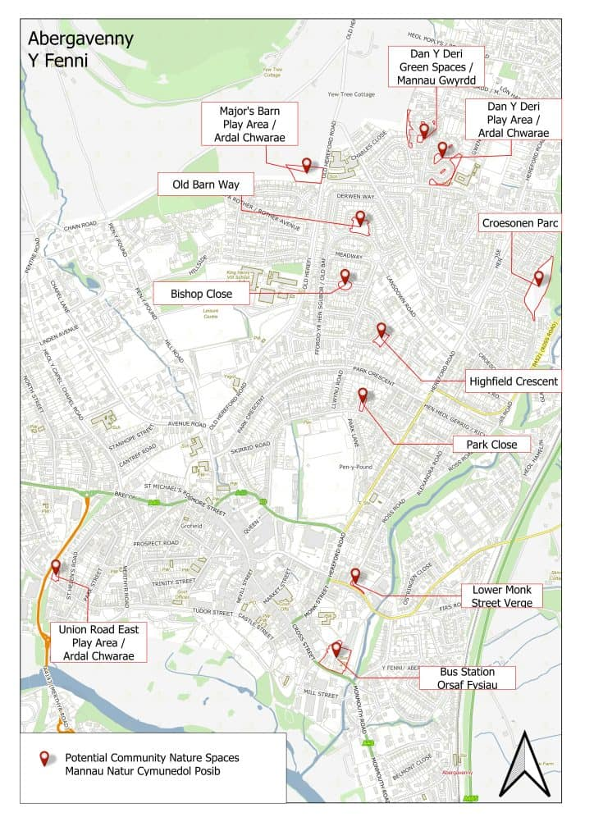
Questionnaires are available to complete in the One Stop Shop or online – here are the questions from 3 -11:
3. We are seeking views on the design and management of play areas and green spaces across Abergavenny for people and wildlife. Which of these sites do you use/ visit? (see map). Please choose all that are most relevant to you.
Major's Barn Play Area
Lower Monk Street Verge
Abergavenny Bus Station
Park Close
Union Road East / St Helen's Close Play Area
Nevill Hall Green Spaces
Dan Y Deri Play Areas
Dan Y Deri Green Spaces
Croesonen Parc
Highfield Crescent Green Space
Bishops Crescent Green Space
Old Barn Way Green Space
Other
4.How do you use the site(s)? Please choose all that are relevant to you.
I live or work overlooking / near the site
I travel through / past (to shops, school, work etc.)
To walk my dog(s)
To sit and relax
To exercise or play sports
For my mental health and well-being
For my children/grandchildren to play in
To meet other people
To see nature
None of the above
Other
5.How regularly do you use/visit these sites?
Daily
Weekly
monthly
Less Often
6.What types of change/improvement would you like to see to these sites?
Opportunities for natural play
Community food growing (mini allotments, fruit and veg growing, community orchards)
Wildlife enhancements
Exercise and health opportunities
Rain Gardens
Other
7.Would you be interested in using the site for food growing such as a mini Allotment / fruit & veg growing / community orchard?
Yes
No
Maybe, with support
8.Which wildlife enhancements would you like to see on the sites?
Reduced grass mowing for wildlife
Planting for pollinators
Planting of shrubs / hedgerows
Tree planting
Boxes for birds / bats / bugs / hedgehogs
Other
9.How concerned are you about the Climate and Nature Crisis?
10.Do you agree that public green and open spaces have a role in addressing the climate and nature crisis?
Yes
No
Maybe
11.Is there something about this site and vicinity that you can share, such as wildlife sightings, local stories, old photographs? Or do you have any additional comments/suggestions?

Consultation ends 31st July 2023.

