ABERGAVENNY TOWN COUNCIL
ENVIRONMENT COMMITTEE
WEDNESDAY 26TH JULY 2023
E85/23: ABERGAVENNY IN BLOOM UPDATE
- WATER SENSOR PROJECT
The installation of 4 sensors has now been implemented, with 2 more and a water level sensor for the water butt to follow. Data is now being received and utilised daily by our contractors.
Sensor 5512 is outside Hacker Youngs on Nevill Street
Sensor 5513 is in the rusty planter outside Tesco
Sensor 5514 is outside Bean and Bread on Lion Street
Sensor 5515 is in the rusty outside the Vape Shop on Frogmore Street
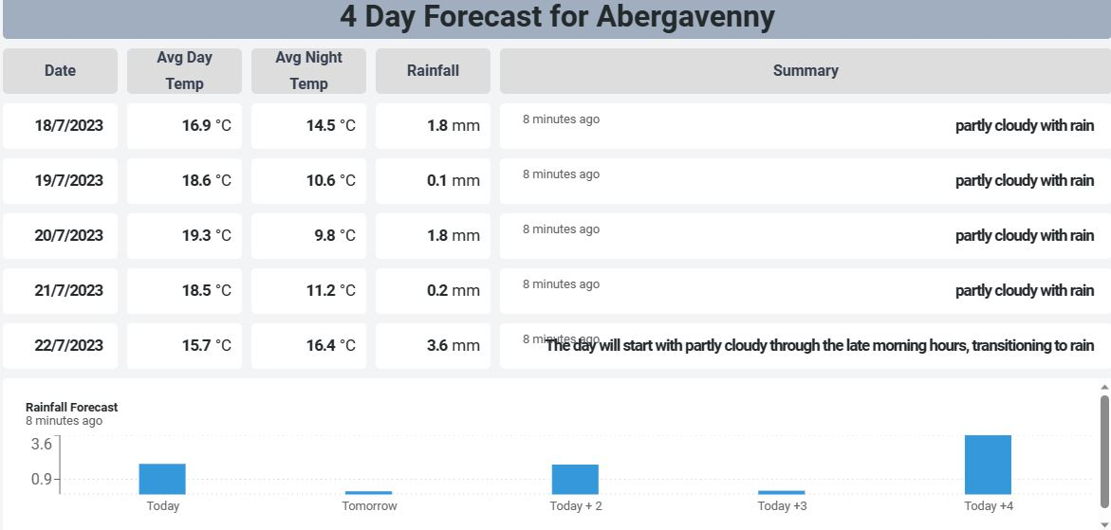
- Four day forecast
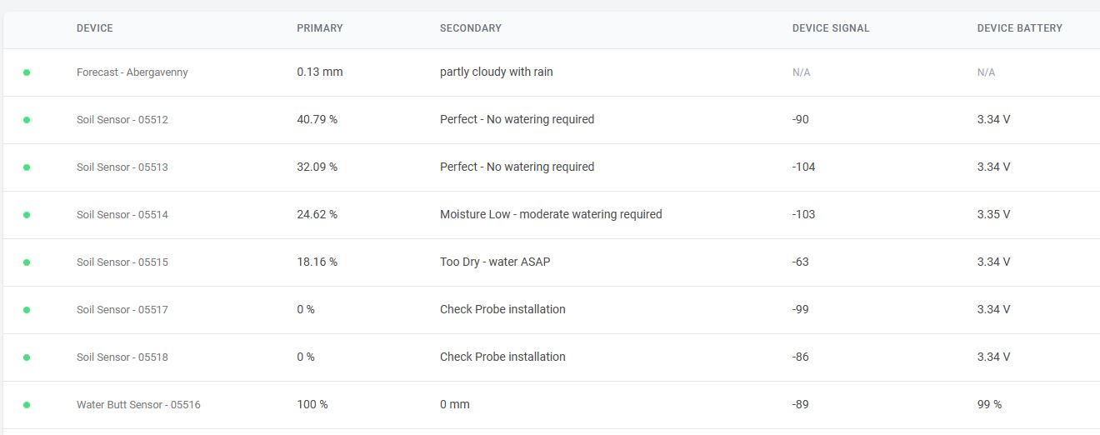
- dashboard
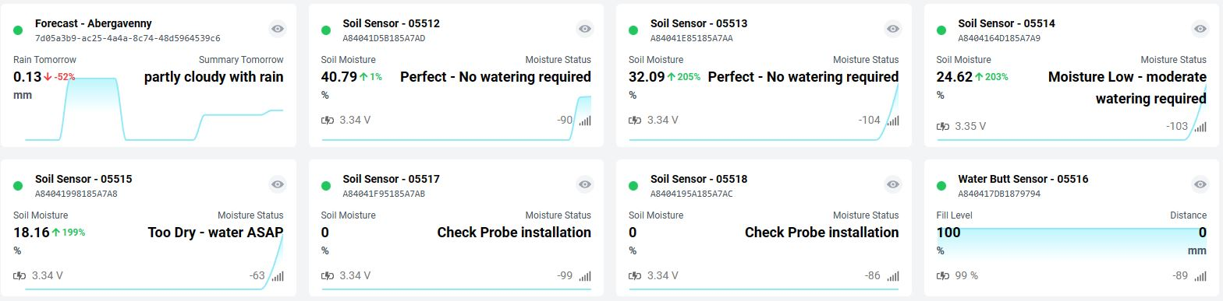
( c) grid view of sensor data
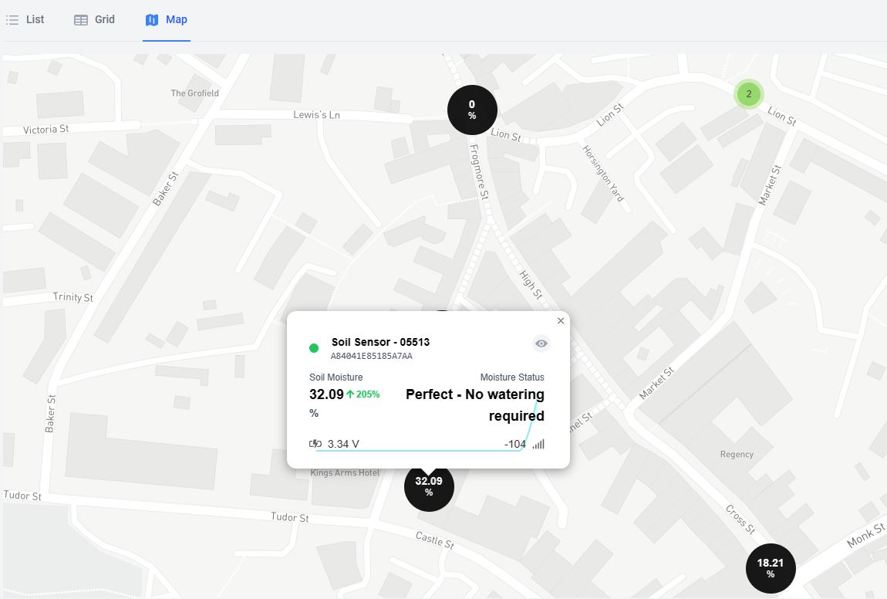
- map showing sensor location and data
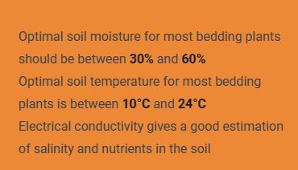
( e) optimal soil moisture levels
So far we can se when watering is carried out due to the spike in water intake, and if weather effects the moisture levels significantly. We can also see an issue with one planter not retaining moisture so we can now look to remedy that and improve the plant health.
The water butt has proved difficult to source and is still ongoing, The area is now clear for it to be installed, and the sensor to monitor the water level has been acquired.

- RHS JUDGES VISIT 31ST JULY 2023
Dale Hector and Brendan Mowforth arrive separately on Sunday 30th July by train (all being well and no strikes or delays). They have the Town Clerk and Cllr Konieczny’s contact details should there be any issues. They are booked to stay in town at The Angel Hotel. Hoping to arrange an early evening meal with them, and the plan on Monday 31st July is for the Town Clerk to park her vehicle at The Angel Hotel so the judges can put their bags in there in readiness for being taken to the train station at 1:15pm. The judging commences at 9am on the 31st July, route is being finalised. Keep Abergavenny Tidy are planning a litter pick on Sunday 30th July and another sweep on the morning of the 31st. Town Team start at 6am on Monday 31dt July so will empty as many town centre bins as possible before judging commences. Carl Touhig and Paul Quayle have been asked to ensure the Refuse ad Recycling Lorries clear through the town centre before 9am if possible.

- AWARD CEREMONIES SEPTEMBER AND OCTOBER 2023
Friday 8th September 2023 – Wales in Bloom awards, Denbigh
Monday 23rd October 2023 – Britian in Bloom awards, London
Two reps can go to the Wales in Bloom awards, at a cost of £17pp.
5 reps can go to Britain in Bloom with costs to be advised.

