ENVIRONMENT COMMITTEE FINANCE REPORT UP TO 30.06.2023

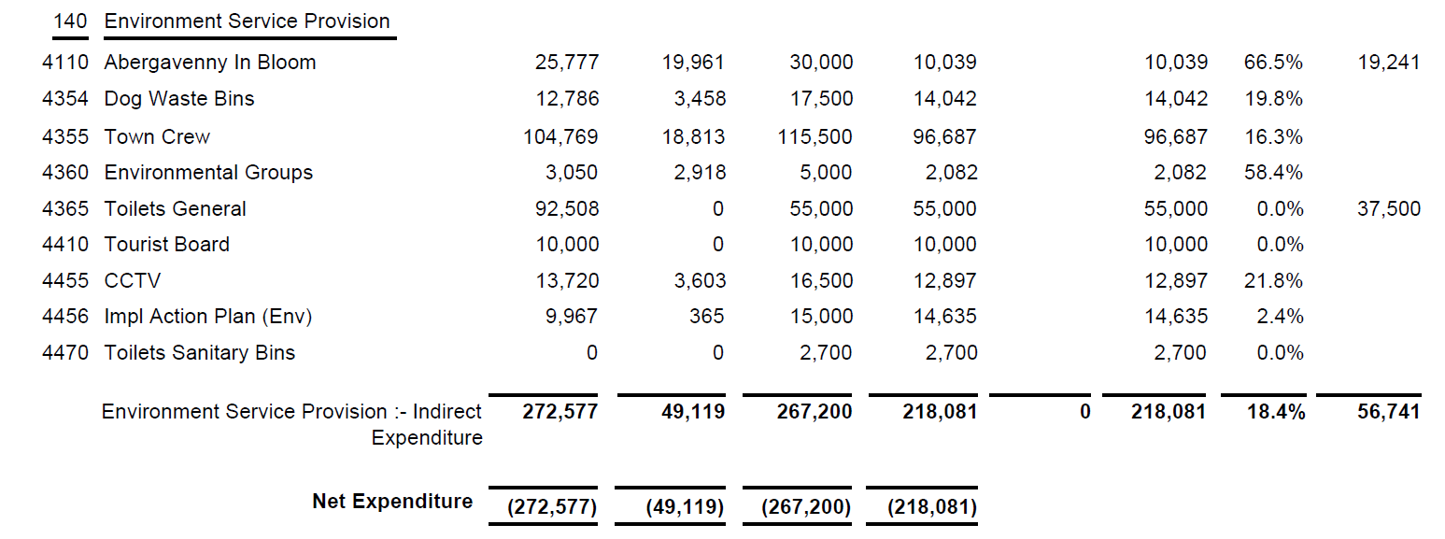

SIGNED AND CONFIRMED AS A TRUE RECORD AS PER AGENDA ITEM E88/23.

CHAIR………………………………………………………

DATE ……………………………………………………...

