ENVIRONMENT COMMITTEE FINANCE REPORT UP TO 31.07.2023 – MONTH 4

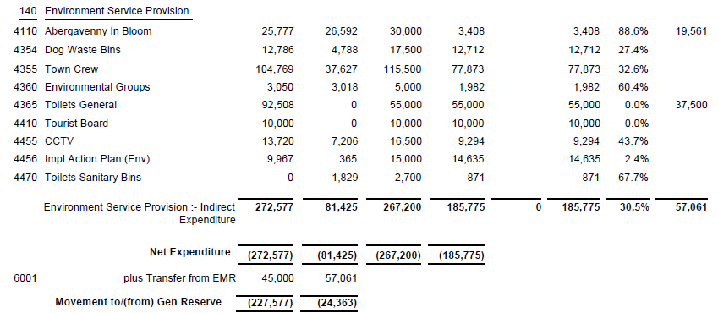

SIGNED AND CONFIRMED AS A TRUE RECORD AS PER AGENDA ITEM E100/23.

CHAIR………………………………………………………

DATE ……………………………………………………...

