ENVIRONMENT COMMITTEE FINANCE REPORT UP TO 30.09.2023 – MONTHS 5 & 6

MONTH 5

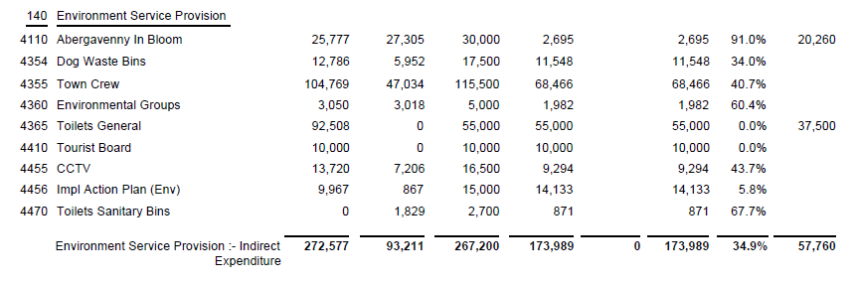

MONTH 6

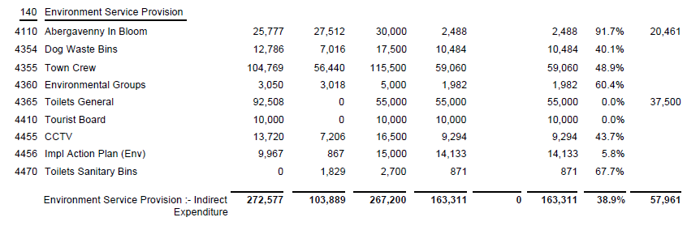

SIGNED AND CONFIRMED AS A TRUE RECORD AS PER AGENDA ITEM E113/23.

CHAIR………………………………………………………

DATE ……………………………………………………...

