ENVIRONMENT COMMITTEE FINANCE REPORT UP TO 31.10.2023 – MONTHS 7

MONTH 7

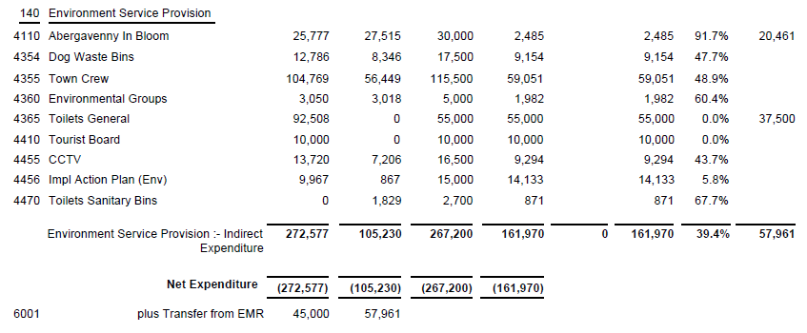

SIGNED AND CONFIRMED AS A TRUE RECORD AS PER AGENDA ITEM E125/23.

CHAIR……………………………………………………… DATE ……………………………………………………...

