E58/23: To receive and approve a Finance update on the Environment Budget headings
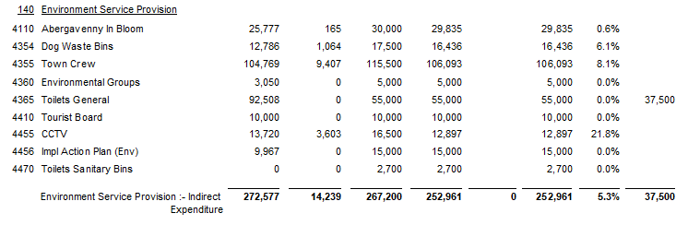

SIGNED AND CONFIRMED AS A TRUE RECORD AS PER AGENDA ITEM E58/23

CHAIR………………………………………………………

DATE ……………………………………………………...

