E96 23 Planter replacement evidence:
Email from Greenfinch Nurseries 06/09/2023:
Please can we ensure that all the planters are watered again soon, I’ve just spent the best part of an hour cutting away dried, dead plant matter from just 2 planters that should be looking at their best now, Anemone are late summer/autumn flowing and yet all the flowers are gone and any buds have dried up. They cannot have had enough water for a prolonged period. Whilst those opposite are looking good, the trees in the dry containers have already turned brown. Our planting is designed to prolong the flowering season in town until the first frosts, especially still looking good for the Food Festival.
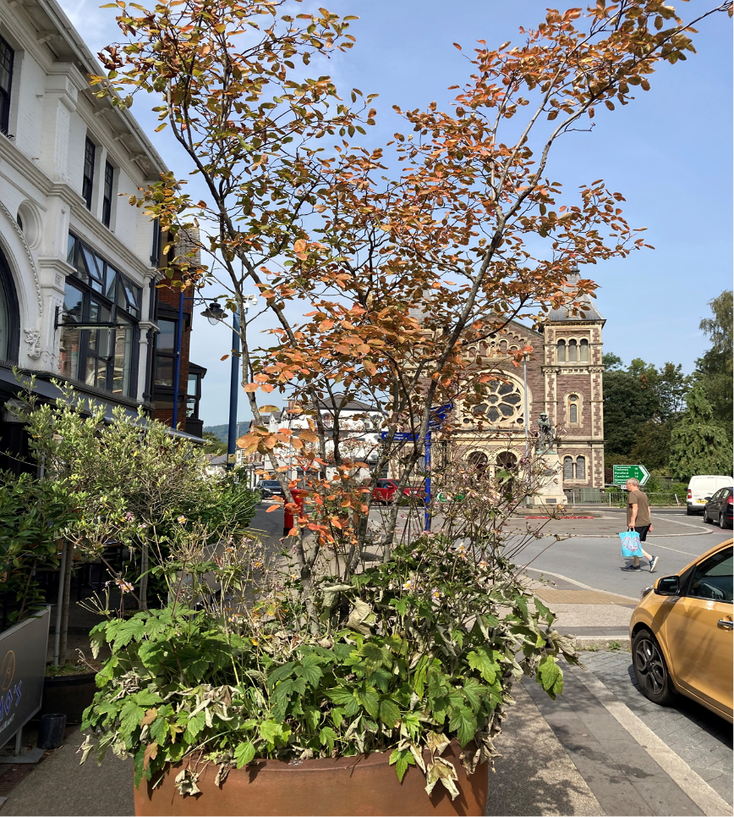

Planter outside Gwagle
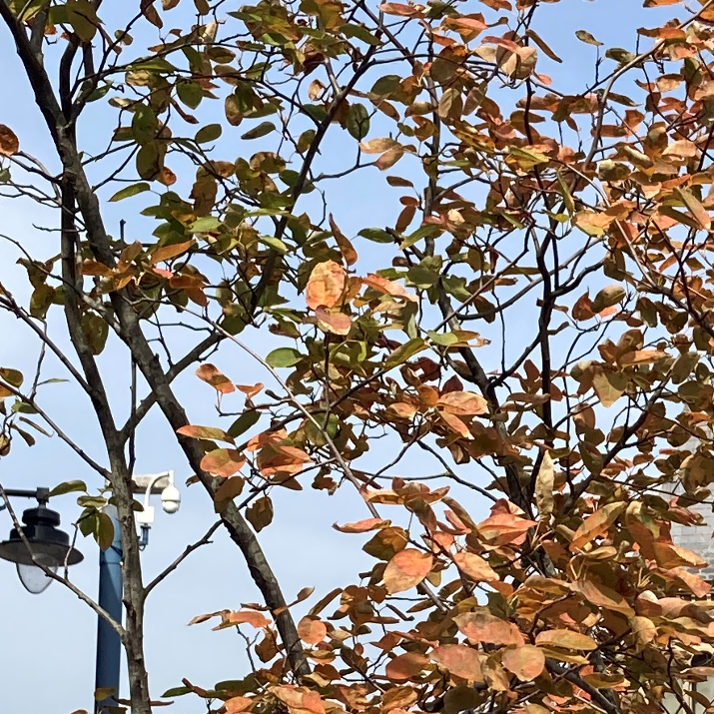

Planter outside Tesco
