PEOPLE AND COMMUNITIES COMMITTEE FINANCE REPORT UP TO 30.06.2023

Month 1 (April 2023):

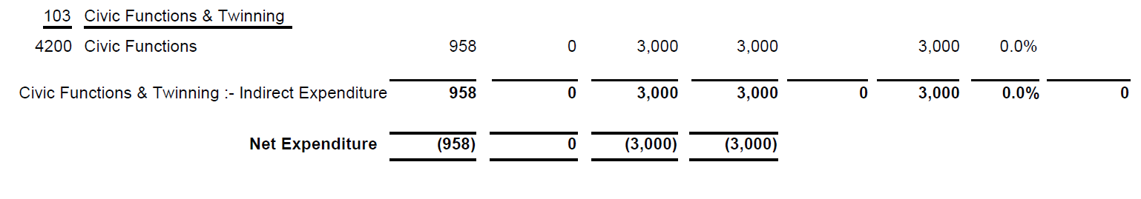
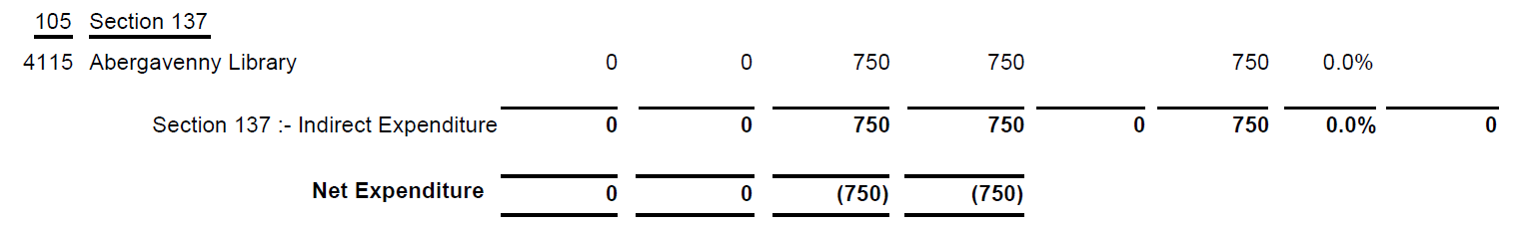
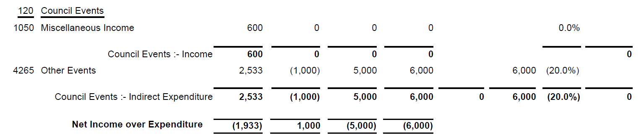

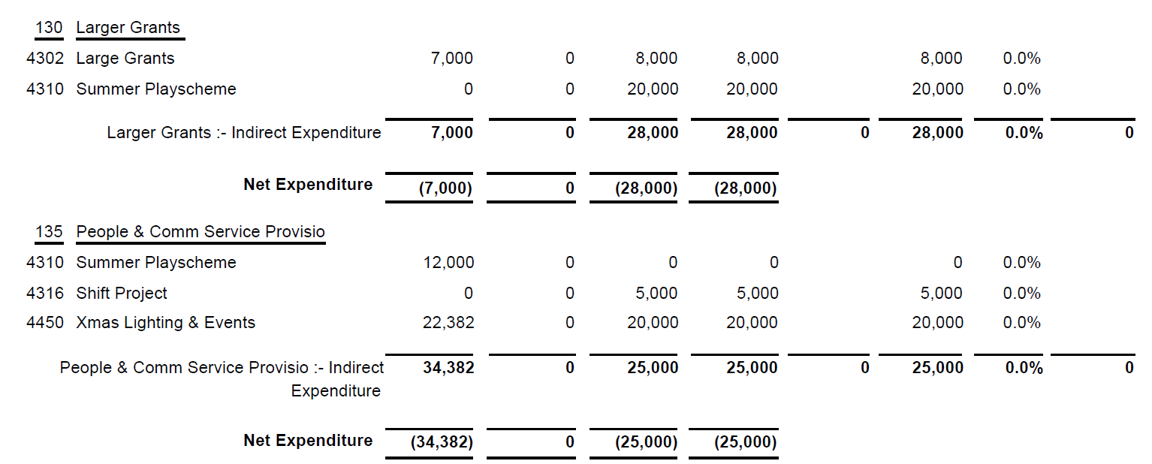

Month 2 (May 2023):

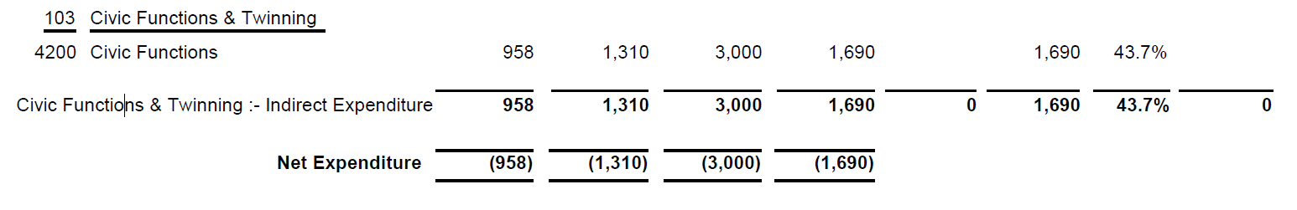
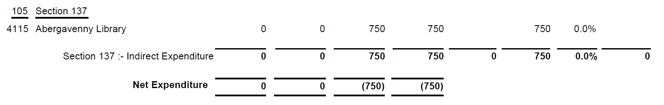
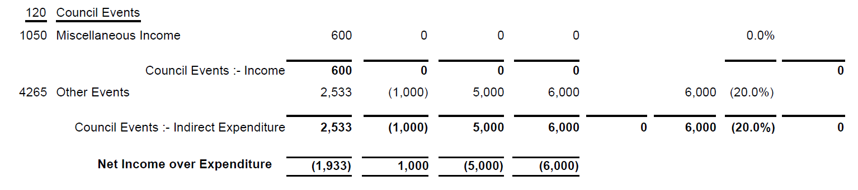

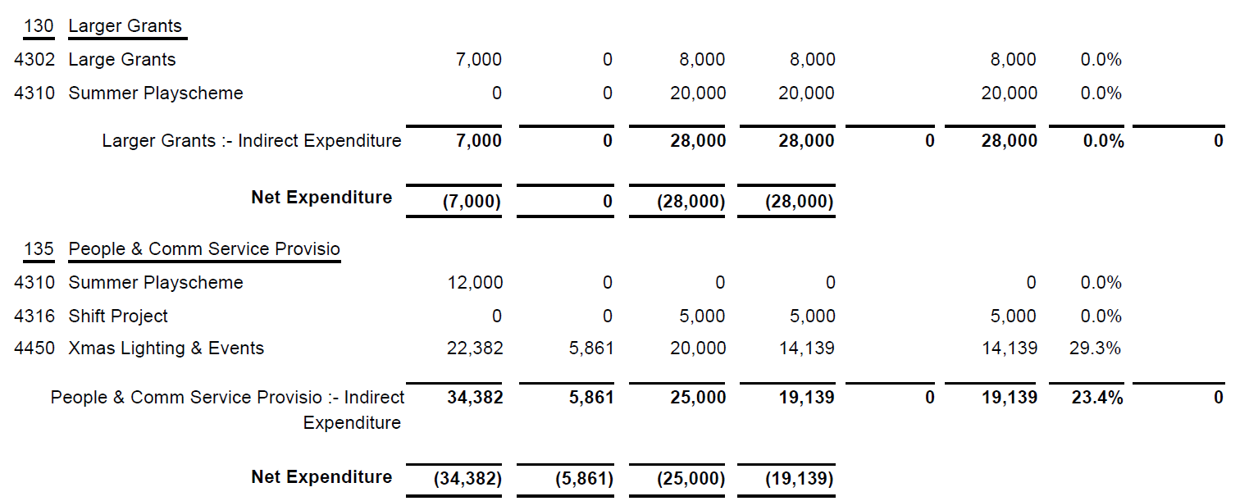

Month 3 (June 2023):

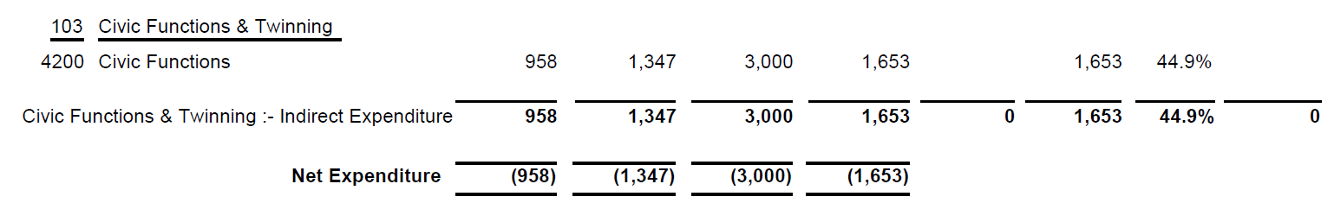
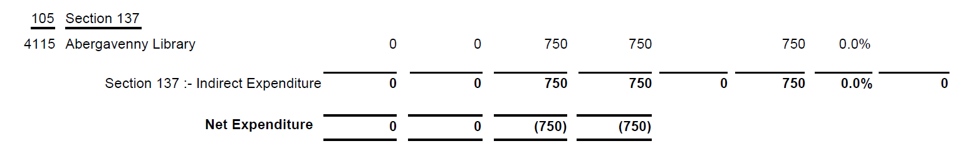
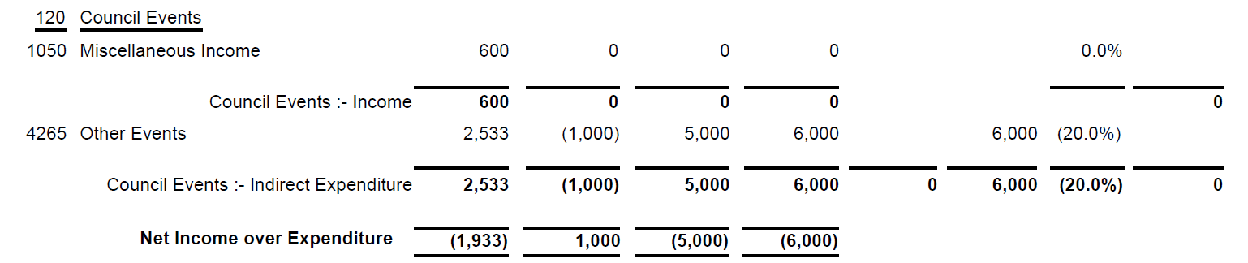

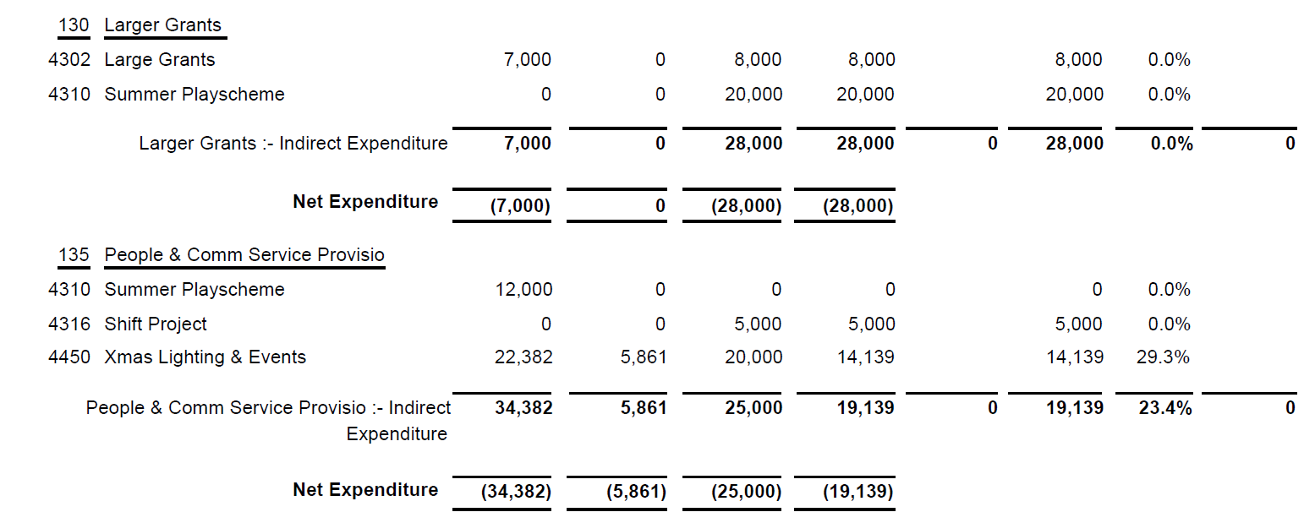

SIGNED AND CONFIRMED AS A TRUE RECORD AS PER AGENDA ITEM PC45/23.

CHAIR………………………………………………………

DATE ……………………………………………………...

