PEOPLE AND COMMUNITIES COMMITTEE FINANCE REPORT UP TO 31.07.2023

Month 4 (July 2023):

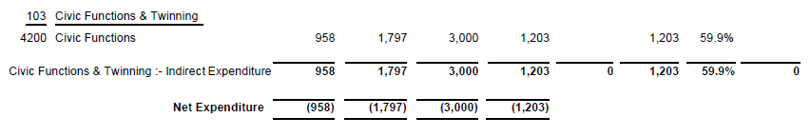
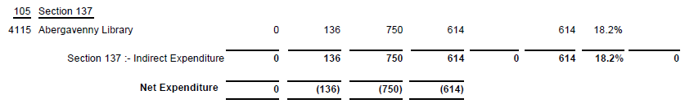
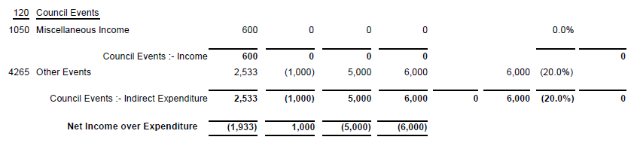

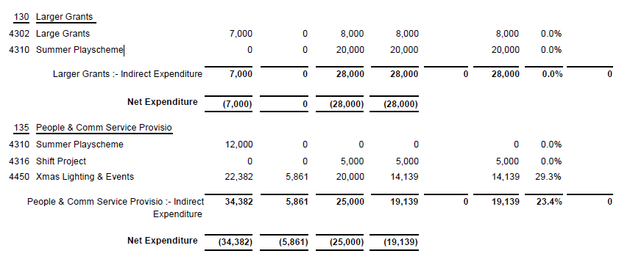

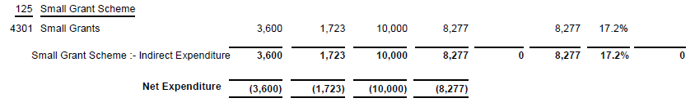

SIGNED AND CONFIRMED AS A TRUE RECORD AS PER AGENDA ITEM PC57/23.

CHAIR………………………………………………………

DATE ……………………………………………………...

