Abergavenny Town Council Annual Report 2022-23

Welcome from the Mayor 2022-23
Dear resident,
Every 5 years the electorate are given the opportunity to vote for their Council representatives and this was the case in 2022. Along with the election came changes in the duties of local councils and changes in our ward boundaries and in some cases the names of the town wards.
The Town Council now covers 6 wards with 17 councillors. Many long serving Councillors took the opportunity to stand down leaving vacancies in all of our wards, the election was well contested with all seats offering a choice of candidates. In the final count 6 Councillors from the previous Council were re-elected and 11 new Councillors joined the Town Council.
Like the previous Council we have worked to create a Strategy and Action Plan for the years leading up to 2027. It is ambitious and we will endeavour to put in place the interventions over the period of the plan.
In April 2023 we were able to host our first Community Dinner in the Abergavenny Community Centre. A hugely successful event to celebrate the achievements of the community and present Good Citizens Awards in recognition of outstanding service to the community.
Wales in Bloom (RHS) asked if Abergavenny would represent Wales in the Britain in Bloom competition in 2023. I’m pleased to report that the groups who make up Abergavenny in Bloom were up for the challenge and the Town has seen the results of their efforts.
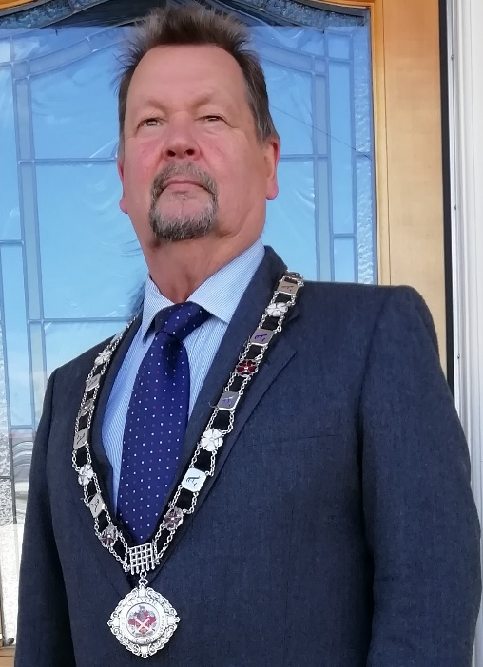
The Council is eager to find ways to communicate with our communities, so we have invested in a new website https://abergavennytowncouncil.gov.uk/ which contains all the information on the elected Ward Councillors, Council meetings, documents, news, events and links to our social media platforms. Members of the public are always welcome to attend Councill meetings, in person or online. There is an opportunity at the beginning of every Council meeting for members of the public to raise issues of concern and address the Council.
Abergavenny Town Council is committed to work with and for all of the people of Abergavenny.
Councillor Tony Konieczny
Mayor of Abergavenny 2022-23

About this report
In the following pages we have set out what Abergavenny Town Council aimed to achieve in 2022-23 and what has been achieved. We also provide a brief outline of what the Council does and contact details.
About Abergavenny Town Council
Abergavenny Town Council is the local council for Abergavenny. The Council has seventeen members covering six wards. Details of all Councillors and wards can be found on our new Town Council website www.abergavennytowncouncil.gov.uk.
The website contains details of all the meetings, meeting attendance by Councillors, details of the allowances paid to Councillors, grant guidance and application form and details of events in Abergavenny. Residents are welcome to attend Council meetings and can address the meeting during the public session at the start of the meeting. All meetings are available as hybrid meetings with remote access. For more information on attending meetings either in person or remotely, please contact the Principal Officer.
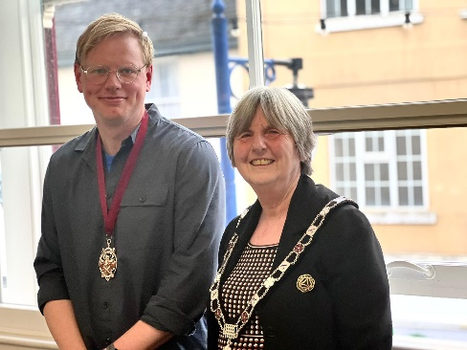
The Town Council’s meetings are now held in the Community Room in the Town Hall. Full Council meet bi-monthly as does People and Communities Committee. Policy and Resources Committee and Environment Committee meet monthly. A number of changes in the Local Government Act have placed extra duties on the Town Council, these include the production of an Annual Report, the creation of a Training Programme for Councillors, the creation of a self-assessment template for the Council, and the ability to hold all meetings in a hybrid format. This came in to force in May 2022. Abergavenny Town Council have been working on producing an Annual Report for residents over a number of years with this being the fifth that it has produced.
Each year at their Annual Meeting held in May, Councillors elect a Mayor. At the meeting in May 2022, Councillors voted in the Mayor and Deputy Mayor (Councillor Tony Konieczny and Councillor Anne Wilde respectively). For 2023-24, these are Cllr Anne Wilde and Cllr Ben Callard.
The Town Council gets almost all its funds from the precept. This is, an additional amount added to the Council Tax bills based on the Town Council’s estimated expenditure. For the financial year 2022/23 the Council’s precept was £481,680.
Pie chart to go in with breakdown

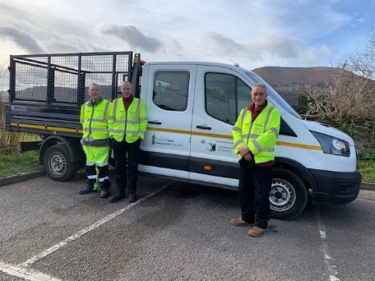
The Town Team comprises of three staff are employed via Monmouthshire County Council’s Grounds Department to look after the town’s wards, and their remit covers litter bins, street cleaning, general maintenance of street furniture, and other reactive ad-hoc duties.

Abergavenny Town Council Strategy & Action Plan
A new plan was created in October 2022. This is based on the priorities outlined in the Wellbeing of Future Generations (Wales) Act 2015. This is a featured agenda item for all committees and is updated regularly. New projects are included in the plan, and those that have been completed are updated accordingly, with all plans being monitored. This action plan can be found on the Town Council’s website www.abergavennytowncouncil.gov.uk or by contacting the Principal Officer to request a copy. This annual report sets out how we’ve performed against the action plan.
So, what did the Town Council do in 2022-23?
The Town Council continues to evolve to meet the needs of the community. We are pleased that we have been able to achieve so much that improves lives of children and young people, tackles an ageing population, improves the natural and built environment and helps the local economy to thrive.
Children & Young People
Our Action Plan states that we work in partnership with other organisations to do more to improve the opportunities for young people, not just through the provision of activities and facilities but also through making available services.
We aim:
- To ensure young people with emerging mental health issues have access to and are offered appropriate services
- To increase opportunities for young people to have a say in what happens in their town
- To improve understanding of whether youth provision in the town is appropriate and sufficient and take forward identified projects
- To provide engaging and stimulating activities for young people
- To promote events for children and young people
What have we achieved?
- We have continued to support Abergavenny Community Enterprise (ACE) Partnership on Hillcrest Road who provide a wide range of support to families and young people and specifically distributed food parcels in the run up to Christmas
- We continued to support Abergavenny Community Trust who run Abergavenny Community Centre where activities for children were available when lockdown was eased, including continued support for their outdoor playscheme
- The Town Council contributed £12,000 to Monmouthshire County Council to run the Summer Playscheme. This playscheme provided free activities for children during the summer holiday
- We continue to contribute £5000 to the Monmouthshire County Council project which offers support to young people aged over 11 years in Abergavenny with emerging emotional wellbeing issues (SHIFT Project)
Challenges of Demographic Change
Abergavenny has an ageing population. The Town Council will ensure there is provision and support for the older generation and will seek innovative ways to bring different generations together. Local organisations support mental health and the Town Council can ensure that appropriate support is available locally. We have a role to play in making representation during the preparation of the Local Development Plan to ensure that planning policies take account of the needs of an ageing population.
We aim to:
- Ensure public service provision accommodates the needs of older people
- Support Community based organisations provide activities that seek to reduce social isolation, improve intergenerational interaction, promote events for older people
- Support services that support older people
What have we achieved?
- We continue to support Mind Monmouthshire by giving £10,000 for the provision of wellbeing services.
- We continue to fund Abergavenny Local Citizens Advice with an annual contribution of £14,000.
- We continue to financially support Abergavenny Community Trust with £10,000 annually, which runs Abergavenny Community Centre providing a variety of activities for older people.
- The Town Council undertook Sight Awareness Training and became a Sight Friendly Organisation. We are working towards making Abergavenny the first Sight Friendly Destination in Wales.
- We paid £13,720 for CCTV in the town which contributed to making the town centre a safer place and reduced the fear of crime. We worked with MCC to determine sites for new CCTV cameras purchased through the Safer Towns Initiative
- The Town Council contribute £45,000 to Monmouthshire County Council for the cleaning and maintenance of the public toilets at Brewery Yard, Castle Street, and the Bus Station, as well as a separate payment for the opening of the toilets during the summer holidays in Bailey Park
- We continue to promote the town’s ‘Friends’ groups that help maintain the different parks in the town as this is a good way for people to meet new people and keep active
Abergavenny in Bloom
The Town Council continued to work alongside community groups on its Abergavenny In Bloom entry which saw the town win a Gold Award for the second time. This was widely supported by many of the volunteers around the town who work so hard.
We were invited by Wales in Bloom to represent Wales in the Town Category for Britain in Bloom, quite an accolade, and one which was grasped by all of the volunteer groups, schools and local businesses working under the Abergavenny in Bloom banner. The municipal planters were 25 years old and had served us well, but needed replacing. The Council purchased a complete new set, enabling us to widen the distribution of municipal planting throughout the town. The old planters were offered to schools and voluntary groups, and all were rehoused and repurposed.

Communities and Businesses are Economically Thriving and Well Connected
The Town Council delivers or financially supports services which contribute to this objective. These include Abergavenny in Bloom, public toilets, Tourist Information Centre, street sweeping and provision and emptying of dog waste bins. To buck the bleak economic forecast and cost of living crisis, the Town Council will play its part alongside business groups, other public sector organisations as well as local and national government.
We aim:
- To have cleaner streets
- To improve the appearance of the town centre
- To have public toilets which meet the needs of users.
- To continue to work with town centre businesses and others to promote the town and what it has to offer
What have we achieved?
- We continued to financially support the town’s festivals. These were the Food Festival, Art Festival, Wall2Wall Jazz Festival, Abergavenny Pride and the Writing Festival.
- We continued to pay for a private contractor to provide and empty nappy and sanitary bins available in the public toilets (£2049)
- The Town Team, made up of three operatives, who work specifically in the six town wards, including emptying the 130 litter bins and street cleaning. They carry out maintenance and reactive work around the town, focussing on the maintenance of the street scene.
- With our support of £10,000 Abergavenny continues to have an extensive Tourist Information Centre (TIC) which is located in the Town Hall.
- We organise and fund a Christmas Lighting scheme at a cost of £22,500. We held a really successful Switch On Event in November 2022, with record numbers in attendance.
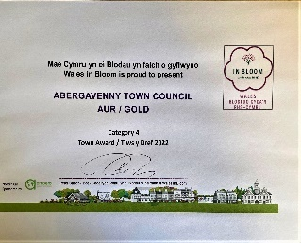
- We managed and maintained the planters, hanging baskets and other floral displays in the town throughout the year at a cost of £25000. This included arranging for all the floral displays to be watered. Abergavenny In Bloom achieved a Gold Award again at the 2022 Wales in Bloom Award Ceremony held in September in Talgarth.
- Greenfinch Nurseries worked with the Town Team to improve their horticultural skills to enable effective maintenance of the beds and planters that we care for.
- The Town Council has committed £50,000 over five years towards the development of the Borough Theatre, including a working relationship with the Melville Centre for the Arts
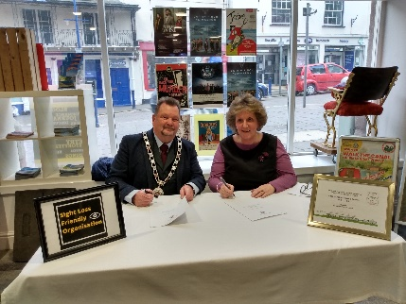
- The Town Council continues to fund the ongoing development of the Melville Centre for the Arts.
- A three year cooperation agreement was signed with Abergavenny and District Tourism Association to continue the support and development of the tourism sector which is so critical to the economy of the area.

Environment and Climate Change
Abergavenny is fortunate to have fantastic greenspaces within the town and more can be done to enhance these spaces for nature and for people. The Town Council will promote partnership working and support for such endeavours such as the delivery of MCC’s Green Infrastructure Strategy. The Town Council has a duty to protect, enhance and promote biodiversity. The Council will engage with local environmental groups. Everyone has a part to play in tackling the climate emergency. The Town Council will monitor the impact of its own practices.
We aim:
- To reduce the use of single-use plastic
- To provide voluntary environmental groups with a more sustainable future including multi-year funding
- To enhance and promote biodiversity
- To improve the maintenance and enhancement of Bailey Park, Linda Vista Gardens and Castle Meadows and the Laurie Jones Community Orchard
- To contribute to the MCC Green Infrastructure (GI) Strategy and resulting projects
- To reduce the incidences of dog fouling in the town
- To deliver on our own Environmental Improvement Plan for key spaces within the public domain
What have we achieved?
- The Town Council has created a Climate Policy which is available on the website
- The Town Council continues to promote Refill Abergavenny which seeks to reduce the use of single use plastic by making refilling water bottles easy to do. Cafes and restaurants in the town display a Refill sticker which indicates that water bottles can be refilled there for free their details are on the Refill app.
- The Town Council paid £247 per week for the emptying of 38 dog bins located around the town.
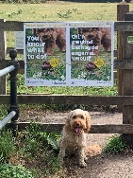
- The Town Council supported the Monmouthshire County Council initiative ‘Give Dog Fouling the Red Card’ and assisted at the Awareness Raising day in August 2022.
- Every month the Town Council commented on planning applications and made recommendations to Monmouthshire County Council.
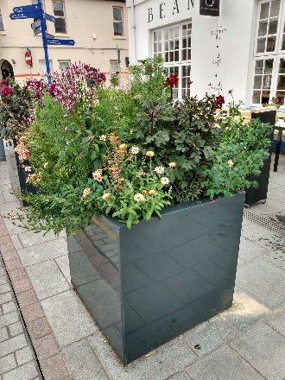
- We started on our phased environmental improvement programme to replace tired areas of planting around the town with colourful, pollinator friendly plants. The beds in front of Castle Street and Tudor Street car parks are now well established and continue to draw a lot of positive comments and admiration. The bed at Station Road has been replanted with pollinator friendly plantings. Work has begun on the Bus Station beds. A new herb wheel planter has been created outside the Community Orchard.
- The Town Council supports multi-year funding for Friends of Bailey Park and Friends of Castle Meadows to help them enhance biodiversity and enable them to plan their activities with greater financial certainty.
How are we becoming a more responsive Town Council?
- The Town Council has a Facebook page and regularly posts updates on the work of the Council and our partners.
- Information of all the Council’s meetings together with all the reports continue to be available on the website.
- The Town Council has responded to various local and national consultations to put forward comments on how different proposals may impact, both positively and negatively, on Abergavenny.

So, what new actions will we be taking forward in 2023-24?
We hope to appoint a new Deputy Principal Officer to complement the team and improve the delivery of services from the Town Council.
We will be working on delivering the Strategy and Action Plan for the tenure of this Council.
We continue to play our part in helping communities in Abergavenny through the promotion of the town and helping with its long-term prosperity.
The Town Council, working alongside Monmouthshire County Council, will continue to refresh the planting in various sites across the town. The next phases will see new planting in the Bus Station and Gabb Square.
We will remodel and rebrand the Town Council website to make it more inclusive and accessible, and to provide links to a variety of social media platforms.
We will work with Monmouthshire County Council and other partners to develop the use of Smart Town Technology
We will continue to monitor the effectiveness of the Town Team dedicated to improving the street scene, including the removal of graffiti, improvement, and maintenance of street furniture, and continued horticultural education to work on the planters and beds around the town.
Through direct funding we will provide play opportunities at Abergavenny Community Centre and through Monmouthshire County Council playschemes.
The Town Council will explore the opportunities for further public art in and around Abergavenny.
We will work with Keep Abergavenny Tidy to monitor litter hot spots around the six wards and develop strategies to reduce littering.

Who are your Councillors?
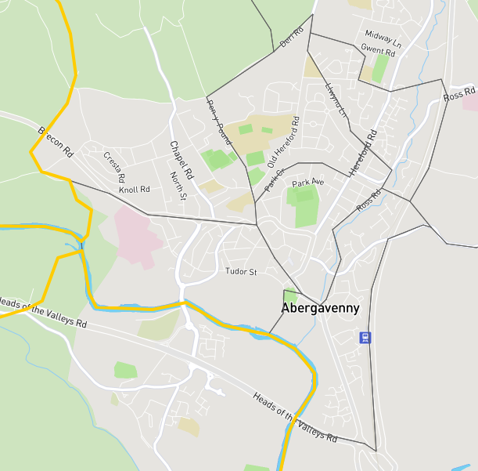

Llanwenarth Citra Ward
Councillor Chris Holland (Independent) chrisholland@abegavennytowncouncil.gov.uk

Cantref Ward
Councillor Sara Burch (Labour) saraburch@abergavennytowncouncil.gov.uk

Councillor Bryony Nicholson (Labour) bryonynicholson@abergavennytowncouncil.gov.uk

Councillor David Simcock (Labour)
davidsimcock@abergavennytowncouncil.gov.uk

Pen y fal Ward
Councillor Gareth Wilde (Labour) garethwilde@abergavennytowncouncil.gov.uk

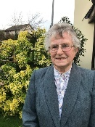
Councillor Maureen Powell (Conservative) maureenpowell@abergavennytowncouncil.gov.uk

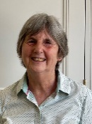
Councillor Anne Wilde (Labour) annewilde@abergavennytowncouncil.gov.uk

Grofield Ward
Councillor Laura Wright (Labour) laurawright@abergavennytowncouncil.gov.uk

Councillor Maurice Barnes (Labour) mauricebarnes@abergavennytowncouncil.gov.uk

Councillor Gethin Jones (Labour) gethinjones@abergavennytowncouncil.gov.uk
Councillor Ben Callard (Labour) bencallard@abergavennytowncouncil.gov.uk

Lansdown Ward
Councillor Mary Ann Brocklesby (Labour) maryannbrocklesby@abergavennytowncouncil.gov.uk

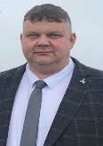
Councillor James George (Independent) jamesgeorge@abergavennytowncouncil.gov.uk
Councillor Martyn Groucutt (Labour) martyngroucutt@abergavennytowncouncil.gov.uk

Park Ward
Councillor Philip Bowyer (Labour) philipbowyer@abergavennytowncouncil.gov.uk

Councillor Tony Konieczny (Labour) tonykonieczny@abergavennytowncouncil.gov.uk
Councillor Kyle Eldridge (Labour) kyleeldridge@abergaevnnytowncouncil.gov.uk

How to contact the Town Council
Contact the Principal Officer by email clerk@abergavennytowncouncil.gov.uk or call 01873 735820. You can pop into the office on the first floor in the Town Hall, located opposite the entrance to the library. You can also contact our Community Engagement and Support Officer on admin@abergavennytowncouncil.gov.uk who is available on Tuesdays and Thursdays.
A summary of what we do
- Paying for emptying of litter bins and street cleaning in the town centre
- Paying Monmouthshire County Council to keep open public toilets in the town and that the toilets in Bailey Park are open at weekends and through the summer holidays.
- Paying for the emptying of sanitary and nappy waste bins in the public toilets
- Paying for the dog waste bins to be emptied weekly
- Providing the Christmas lights in the town and arranging the ‘switch on’ event
- Paying for CCTV in the town
- Management and maintenance of all the town centre planters, hanging baskets and other floral displays around the town, and enhancing and promoting biodiversity
- Financial support to ensure that the town has a Tourist Information Centre
- Supporting local events and festivals

