E134/23: REPLACEMENT PLANTERS REPORT

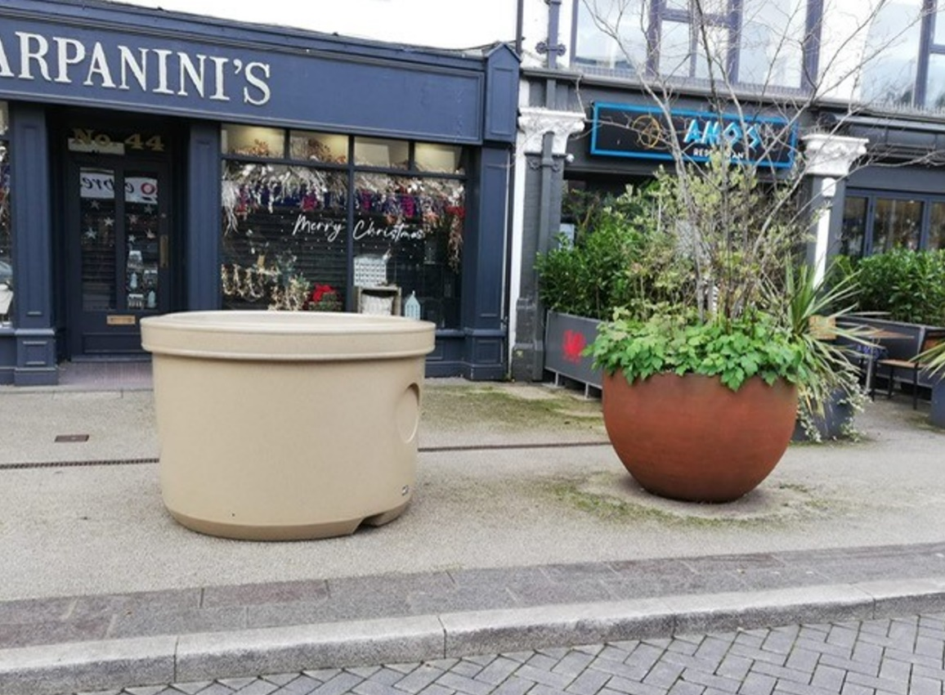

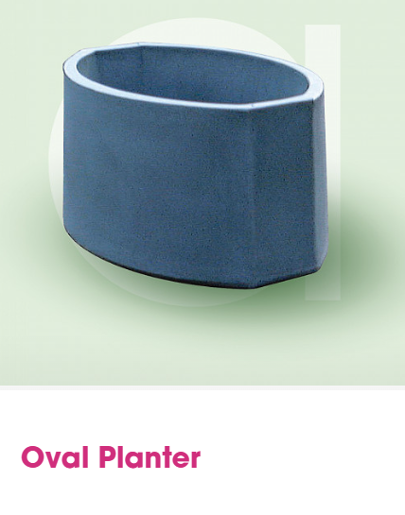
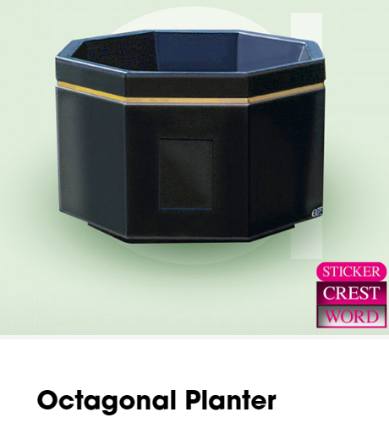

PRICES FOR THE ABOVE PLANTERS:
Octagonal in Tudor brown mottle: £456.57 each
Oval in Tudor brown mottle: £334.40 each

Email request from Greenfinch Nurseries:

Hi Sandra,
We wanted to make a suggestion regarding the planters on Frogmore St. We are in agreement that the current pots are not strong enough for the location and that those that are already broken or particularly vulnerable to damage should be removed. If these broken planters are removed and the trees and plants cared for, could we not replace them with possibly fewer, but better quality pots? These would need to complement the design of the current planters to maintain the contemporary and vibrant appearance of this street, something which we are regularly told by members of the public is what draws them to Abergavenny as a destination. We are in communication with the fabricator who built the two metal planters currently outside the Abergavenny Hotel, they are a local business based in Rhymney, and hope that they will be able to offer a reasonable price. These planters have proved very successful, they are robust and can be moved using a folk-lift truck.
Replacing all the containers at once will be costly in terms of time and materials, and will create waste where planters are currently still sound.
We'd love to know the thoughts of the council on this.
Best wishes, Keri and Josie.

DISCUSSION: Create a tender asking companies to submit designs and suggestions for replacement planters – amount and size to be decided, as well as locations. Lifespan – requirement that the longevity match that of the current Amberol stock which is being utilised in other locations. Encourage sustainable solutions, using materials which will make them fit the look and feel of this area of the town centre. Ask the businesses on the street to be part of the process – engagement to ask for pinions and thoughts, locations and style.

