E138/23: ENVIRONMENT COMMITTEE FINANCE REPORT UP TO 30.11.2023 – MONTH 8

MONTH 8

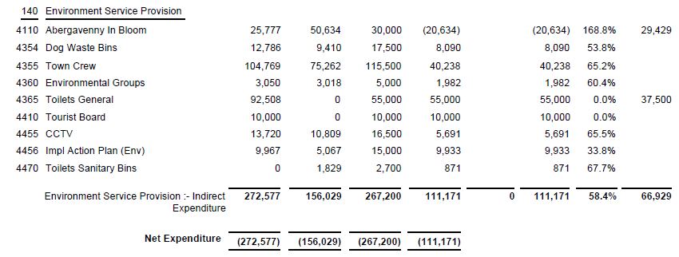

SIGNED AND CONFIRMED AS A TRUE RECORD AS PER AGENDA ITEM E138/23.

CHAIR……………………………………………………… DATE ……………………………………………………...

