PEOPLE AND COMMUNITIES COMMITTEE FINANCE REPORT UP TO 31.01.2024

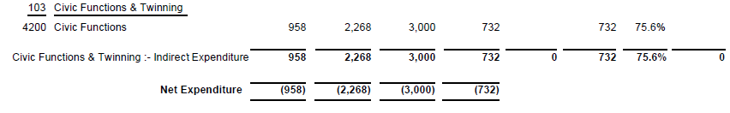
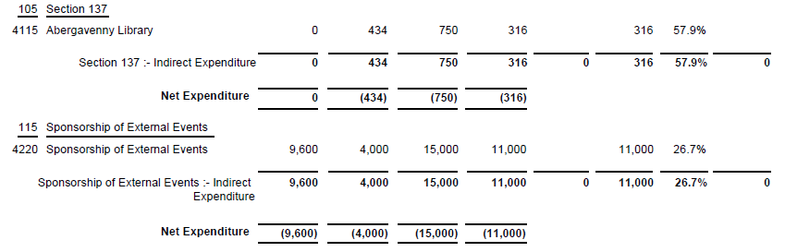

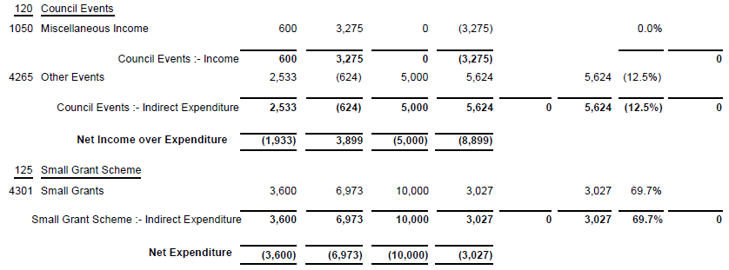

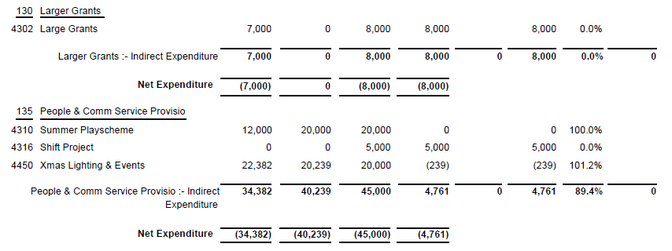
SIGNED AND CONFIRMED AS A TRUE RECORD AS PER AGENDA ITEM PC22/24(a).

CHAIR……………………………………………………… DATE ……………………………………………………...

