PEOPLE AND COMMUNITIES COMMITTEE FINANCE REPORT UP TO 31.12.2023

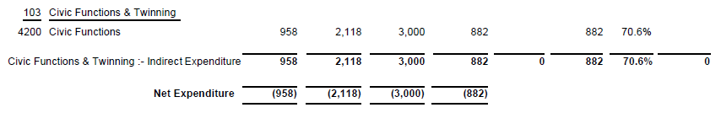
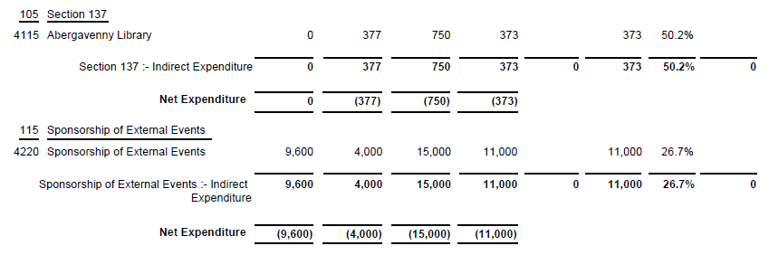

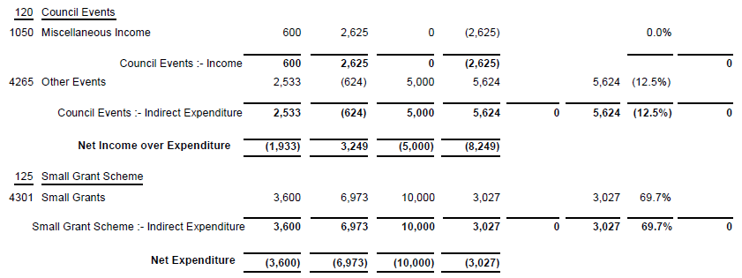

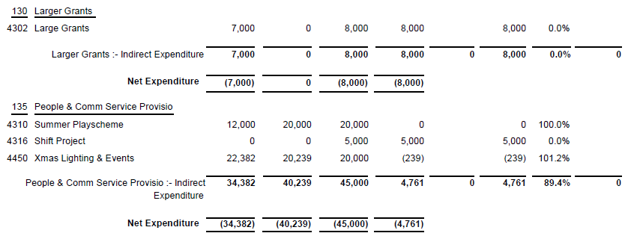
SIGNED AND CONFIRMED AS A TRUE RECORD AS PER AGENDA ITEM PC07/24(a).

CHAIR……………………………………………………… DATE ……………………………………………………...

