DATED 26th January 2024

ABERGAVENNY TOWN COUNCIL
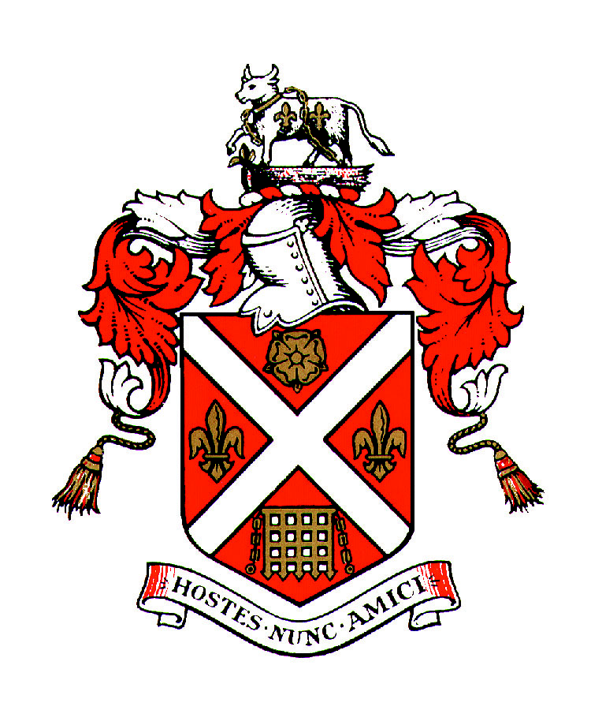

and

ABERGAVENNY ARTS FESTIVAL

_________________________________
COOPERATION AGREEMENT
for the provision of funding for
ANNUAL FREE COMMUNITY ARTS FESTIVAL
_________________________________

AGREEMENT
DATED: 26TH JANAUARY 2024
BETWEEN:
- ABERGAVENNY TOWN COUNCIL of Town Hall, Cross Street, Abergavenny (the “Council”).
- ABERGAVENNY ARTS FESTIVAL (AAF)
COOPERATION AIMS
- Abergavenny Town Council has statutory duties under the Well Being of Future Generations Act and has identified a number of organisations that can help the Town Council fulfil their duties. ___AAF_______ is one such organisation.
- ___AAF___ can help the Council address the identified priority areas which are protecting and enhancing the natural environment.
AAF encourages eco-friendly practices, sustainability and practices that demonstrate awareness of environmental issues. Workshops will include activities that focus on looking after the natural environment. We aim to serve as a platform for local artists and makers to create community works with the visitors, to highlight the environmental projects run by various groups in town, who are also invited to the festival.
- Abergavenny Town Council support _AAF__ in its aims to provide ongoing and voluntary improvements _in widening accessibility to the arts for all the community__.
- _AAF seeks security of funding to enable the group to have a sustainable future and to create increased capacity to develop the biodiversity development, including the new fringe festival (which invited the whole town to become involved with the window art trail and arranging their own related activities). The financial support would enhance programming, attract more diverse artists, and foster community engagement, which will contribute to the Festival’s long-term success and ecological impact.

COOPERATION SERVICES

During the Term of this Agreement, the Council shall provide capital and revenue funding to support the work of AAF__ as set out in Annex 1.

_AAF will take appropriate steps to ensure value for money when letting contracts and that appropriate management arrangements are put in place to ensure that the quality of work is to a specified standard.

The agreement is to incorporate:

Capital and revenue funding to undertake the projects outlined in Appendix 1.

In the event that any of these projects cannot be undertaken the Council will consider favourably allowing _AAF_ to use such funds for other, approved, projects in line with the cooperation aims outlined above.

DELIVERABLES

_AAF_ will deliver against the Wellbeing of Future Generations Act and the Town Council Strategy & Action Plan to implement changes to enhance biodiversity which works towards Section 6 of the Environment Act. Details of deliverables are set out in Annex 2.

TERM AND TERMINATION & INDEMNITIES

Subject to earlier termination in accordance with its terms, this Agreement shall commence on the _1st June 2024_ and shall continue until _30th June 2026.

This agreement may be terminated at any time by either party giving at least 12 months' clear written notice to the other party.

There will be a review point every 12 months during the term of this agreement.

_AAF_ should notify the Council at the earliest opportunity should the Group be considering closing down the project or that the project is in financial difficulty. This would enable the Council to consider its options regarding future funding.

_AAF_ has in place appropriate insurances which includes public liability insurance. The group has sole responsibility for dealing with any claims from accidents or other events resulting in loss or injury even if the activity was partially funded using Council funding.

PAYMENT

The Council will pay £3000_ for AAF_ in _2024_ following the signing of the agreement.

Thereafter the Council will pay the annual sum in 1 instalment(s); the instalment will be paid prior to the Festival, which takes place 15th June 2024_. Future year payments would be subject to satisfactory annual review.

VARIATION TO THE AGREEMENT

Should either party wish to discuss a significant variation to the agreement, representatives shall meet to agree such variations. Significant variations will be added to this Agreement as supplementary appendices.

PERFORMANCE MANAGEMENT

As a minimum, the Council and _AAF_ will meet annually. This will involve a visit to _the town hall_ to receive a presentation from the group. The performance measures are set out in Annex 3.

One week before the visit an update report will be sent to the Town Clerk for circulation. The annual report structured under the agreed objectives should capture what has worked well and also what hasn’t worked well. It is important for both parties to be open and transparent to aid greater understanding. This report will form the basis for any changes to the deliverables for the coming year.

During the year, copies of newsletters and reports should be circulated to the Town Clerk for circulation to all Councillors.

Cooperation Meetings

Both parties are able to request that a cooperation meeting is convened. This could be to discuss and explore potential issues or new proposals. Both parties are encouraged to view this as a meaningful partnership, with both parties wanting the same outcome.

RESOLUTION OF DISPUTES

If there is a dispute between the parties concerning any matter arising from or in connection with this Agreement, the parties will use reasonable endeavours to settle the matter in accordance with the dispute resolution procedure set out below.

Any dispute which has not been resolved between the Nominated Representatives (to be nominated by the Town Council at the May Council meeting) within fourteen (14) days of the matter being raised, may be escalated by either party to the Chair of AAF and Full Council Committee by notice in writing.

PUBLICITY

_AAF_ will acknowledge the support of the Town Council whenever possible on their website, social media, printed materials etc.

Signed on behalf of Abergavenny Town Council  By Name: | ) Signature:  ) Date:

Signed on behalf of __AAF____  By Name: EMMA KATE BEVAN-HENDERSON | ) Signature: E-HendersonKBevan  ) Date: 26th January 2024

ANNEX 1
COOPERATION FUNDING

PROJECT PLANS

ANNEX 2
DELIVERABLES
THE WELL-BEING OF FUTURE GENERATIONS ACT (WALES) 2015.
How this is reflected in the existing provision and ongoing projects and how this benefits the people of Abergavenny and visitors now and in the future.
A PROSPEROUS WALES

A MORE RESILIENT WALES

A HEALTHIER WALES

A MORE EQUAL WALES

A WALES OF COHESIVE COMMUNITIES

A WALES OF VIBRANT CULTURE AND THRIVING WELSH LANGUAGE

A GLOBALLY RESPONSIBLE WALES

____________________________________________________________________

SECTION 6 – ENVIRONMENT (WALES) ACT 2016
Biodiversity and resilience of ecosystems duty
ANNEX 3
PERFORMANCE MEASURES

The annual report will include the following measurements:

(The Update Report could include a number of case studies to reflect the impact of activity on individuals or groups.)

