Abergavenny Food Festival
Artist / Maker Bettina Reeves has been the creative inspiration behind the Festival’s much anticipated annual installations which animate the beautiful Victorian Market Hall. Each year there is a new theme. Her brilliant inventions, unveiled ahead of the Festival weekend, remain in place throughout the year. Thanks to support from Abergavenny Town Council, both local residents and visitors to the town can enjoy them.
The Food Festival has commissioned Bettina to decorate the Market Hall since its inception in 1999. Previous themes have included: kitchen gardens, wildlife of the River Usk, angelic angels, sea-life, food on plates, utensils, a herd of sheep, bees and butterflies, fish, flowers, and barn owls. Researching and painting her subjects is followed by three weeks of intense design and making (approximately 1500 hours), working with volunteers of all ages to realise her vision.
Lots of local talent
“My enthusiastic team has gained in confidence and creative skills over the years,” says Bettina. “They have sculpted with willow, wire, cardboard and paper, and many have used their sewing skills – by machine and hand – to great effect. Working with willow has been a particular joy; a lovely organic and pliable material for celebrating creatures who move so beautifully in the natural environment.”
She knows the project is eagerly anticipated. “New friendships are formed. There is great a sense of camaraderie, creativity and pride in the finished product. Long hours, hard work and tenacity go into the making, but it’s also great fun; the pleasure of a unique shared experience.”
Creative teamwork
“Tina put me onto fish – a John Dory – in 2018. I got so attached to this fish that I named it ‘Dom Alexander Joly’ and secretly put the initial DAJ on the body. Why? I always mix up ‘John Dory’ with the comedian ‘Dom Joly’, and the process of making this fish made me feel like ‘Alexander McQueen’ so I used ‘Alexander’ as a middle name!” Mayumi Takahagi
“I’ve always enjoyed model making and DIY, and the Food Festival decorations allow me to indulge myself. Not to mention the glorious food we get to eat. Funnily, my most treasured memory is making a garden spade.” Oliver Barton
“In the year of the sheep we became experts in rag-rugging and crochet. First time round, I quilted lemons to go on plates of fish. They looked so impressive and I was so proud of what I’d done. That’s it actually – the camaraderie and feeling of pride about what we achieve in that big group, always in a ridiculously short time. And Tina bringing it all together. It’s a miracle.” Cath Barton
“Creating with others is a highlight of my year. Tina has such creative vision and knows exactly how to achieve it. Hard work, but the results are amazing! Covering the willow frame of the second otter was a huge task and took at least three people working together to make all the pieces fit. It was wonderful seeing it gradually come to life. And all the joins were in herringbone stitch, which I really enjoyed.” Judith Skeels
“I have volunteered at Tina’s workshops for several years now, and always really enjoy them. My skills are mediocre, but I learn something new every time, and wonder at the abilities of the truly skilled as they turn willow and fabric into almost living creatures. The pride at seeing the whole ensemble in the Market Hall is immense.” Caroline Fairclough
Total direct cost to Abergavenny Food Festival for the Market Hall decorations is £12,604.
The decorations stay up until the next ones are ready and really bring Abergavenny Market Hall to life. They are a real talking point and much loved throughout the community.
Making the decorations with other people is a very positive way to bring people together and increase their wellbeing and address isolation.
We fully credit Abergavenny Town Council for your contribution, including this blog on our website:
https://www.abergavennyfoodfestival.com/tales-of-the-making/
On our Facebook page:
https://fb.watch/oLh7aGzTjI/
On Twitter / X
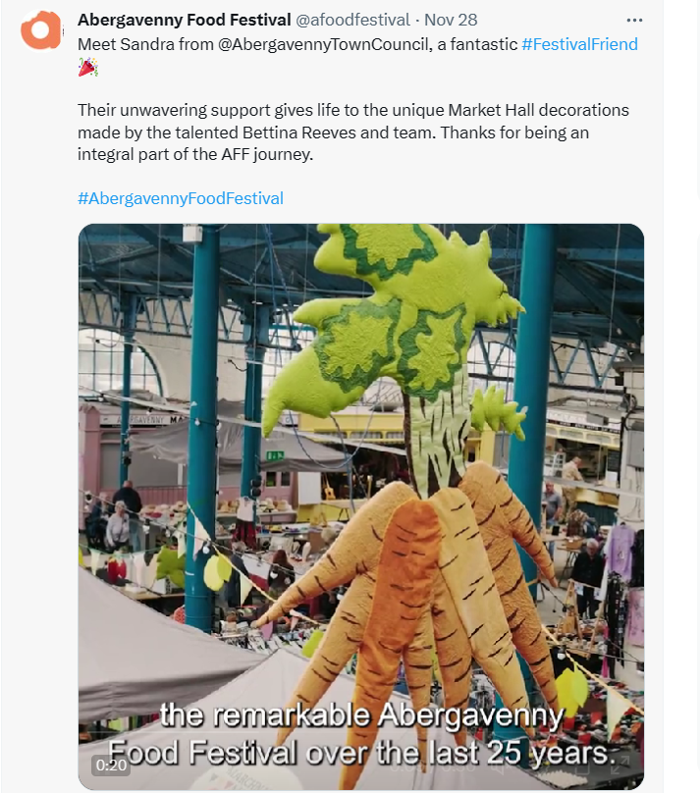

And on Instagram:
https://www.instagram.com/reel/C0MF5FzsqGt/?utm_source=ig_web_copy_link&igshid=MzRlODBiNWFlZA==

