DATED: 2024 | DRAFT MARCH 2024

ABERGAVENNY TOWN COUNCIL
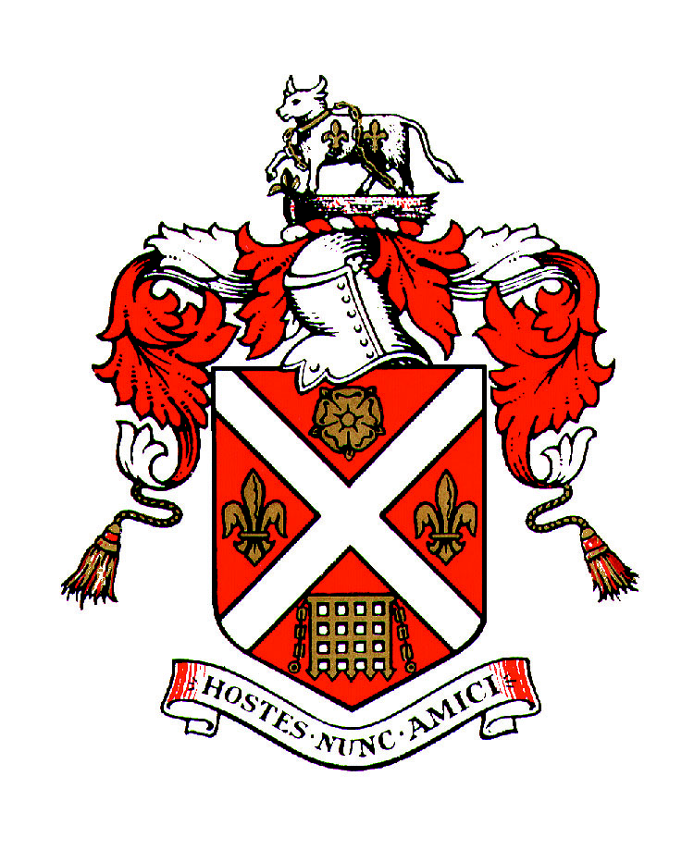

And

Melville Centre for the Arts Community Interest Company

_________________________________
COOPERATION AGREEMENT

for the development of Abergavenny’s Centre for the Arts
_________________________________

AGREEMENT
DATED: 2024
BETWEEN:
- ABERGAVENNY TOWN COUNCIL of Town Hall, Cross Street, Abergavenny (the “Council”).
- The Melville Centre for the Arts CIC of 3 - 5 Pen y Pound, Abergavenny NP7 5UD (“MCA CIC”)
COOPERATION AGREEMENT AIMS
- Abergavenny Town Council has statutory duties under the Well Being of Future Generations Act and has identified a number of organisations that can help the Town Council fulfil their duties. MCA CIC is one such organisation.
- The directors of MCA CIC seek active community focused partners 1) to help ensure the sustainability of the Centre, 2) to help provide evidence to grant making organisations that the emerging plans for development of the Melville site as an Arts Centre have been shaped by community consultation, 3) to support the Melville in its journey to become a community asset, yielding social and economic benefits for the area, and 4) to help MCA CIC operate at significantly less cost to the environment than at present.
- MCA CIC will help the Town Council address its aims in identified priority areas by promoting the wellbeing of children & young people, responding to the challenges of demographic change, reducing Monmouthshire’s carbon footprint and protecting and enhancing the natural environment. MCA CIC will work with the Town Council to increase the number of low cost, low barrier, environmentally friendly events and activities available for all generations and to make particular provision young people at weekends and during school holiday time.

- SERVICES
  - During the Term of this Agreement, the Council shall provide capital and revenue funding to support works of the Company as set out in Annex 1.
  - The Company is to take appropriate steps to ensure value for money when letting contracts and ensure that appropriate management arrangements are put in place to ensure that the quality of work is to a specified standard.
  - The agreement is to incorporate:
    - Funding of arts related projects, events and activities with outcomes contributing to the achievement of the Town Council’s objectives
    - Funding of services, materials and equipment contributing to the achievement of Abergavenny Town Council’s aims in relation to: the wellbeing of the community, particularly of children and young people, inclusivity, and the support and enhancement of the natural environment
    - Funding to invest in energy efficiency/energy generating measures which will result in reduced energy consumption and a lower carbon footprint.
- DELIVERABLES
  - MCA CIC is to deliver against Abergavenny Town Council’s environment and bio-diversity obligations, the seven Gwent Public Service Board Well-Being Objectives and the Town Council Strategy & Action Plan. Details of deliverables are set out in Annex 2.
- TERM AND TERMINATION & INDEMNITIES
  - Subject to circumstances requiring earlier termination in accordance with its terms, this Agreement shall commence on the April 1st 2024 and continue until March 31st 2027.
  - This agreement may be terminated at any time by either party giving at least 12 months' clear written notice to the other party.
  - There will be a review point in October every 12 months during the term of this agreement.
  - MCA CIC should notify the Council at the earliest opportunity should the Company be considering closing down the project or if the project is in financial difficulty. This would enable the Council to consider its options regarding future funding. The Town Council understands the current arrangement with the landlord (Monmouthshire County Council) is a Licence to Occupy, and work is underway on negotiating a proposed long leasehold/freehold community asset transfer.
  - MCA CIC should have in place appropriate insurances which include public liability insurance. The Company has sole responsibility for dealing with any claims from accidents or other events resulting in loss or injury even if the activity was partially funded using Council funding.
  - MCA CIC will have in place a safeguarding policy and will ensure that this policy is adhered to in the delivery of services and that it is periodically reviewed.
  - MCA CIC will have adequate policies and provision to support all staff in their continual development and wellbeing during the period of employment with MCA CIC.
- PAYMENT
4.1 Each year, following the signing of this agreement, the Council will contribute £10,000 towards the costs of projects, events and activities. Thereafter the Council will pay the annual sum as set out below in two instalments; the first instalment in April and second instalment in October. All payments will be subject to satisfactory annual review.
2024/25 | 2025/26 | 2026/27
£10,000 towards the delivery of projects, events, and activities | £10,000 towards the delivery of projects, events, and activities | £10,000 towards the delivery of projects, events, and activities
£10,000 | £10,000 | £10,000

- VARIATION TO THE AGREEMENT
  - Should either party wish to discuss a significant variation to the agreement, representatives shall meet to agree such variations. Significant variations will be added to this Agreement as supplementary appendices.
- PERFORMANCE MEASURES
  - The MCA CIC performance measures are set out in Annex 3. As a minimum the Council and MCA CIC will meet annually in November at the Melville Centre to receive a presentation from the directors, review performance against these measures and identify any issues for deliverables going forward.
  - At least one week before the annual meeting in November between Abergavenny Town Council and MCA CIC, the MCA CIC will forward a report on performance against the measures alongside an up to date copy of accounts to the Principal Officer for circulation.
7. INFORMATION SHARING
7.1 It is important for parties to be open and transparent to aid greater understanding. Directors will forward the MCA CIC Annual Report as presented to its AGM in July to the Principal Officer for circulation.
7.2 During the year, the following will be circulated to the Principal Officer for circulation to all Councillors: MCA CIC’s newsletters to subscribers, Quarterly Performance Reports, updates on activities, and reports on consultation exercises.
8. COOPERATION MEETINGS
8.1 Both parties can request that a cooperation meeting is convened. This could be to discuss and explore potential issues or new proposals. Both parties are encouraged to view this as a meaningful cooperation agreement, with both parties wanting the same outcomes.
9. RESOLUTION OF DISPUTES
If there is a dispute between the parties concerning any matter arising from or in connection with this Agreement, the parties will use reasonable endeavours to settle the matter in accordance with the dispute resolution procedure set out below.
Any dispute which has not been resolved between the Nominated Representatives (to be nominated by the Town Council at the May Council meeting) within fourteen (14) days of the matter being raised, may be escalated by either party to the Chair of the Board of Directors and Full Council Committee by notice in writing.
10. PUBLICITY
MCA CIC will acknowledge the support of Abergavenny Town Council, using the Abergavenny Town Council crest or logo with appropriate prominence on their website, social media, printed materials etc.
Posters for all events will be shared on the Town Council website and social media platforms. These will be forwarded to the Principal Officer for uploading as and when required.

Signed on behalf of  Abergavenny Town Council  By Name: | ) Signature:  ) Date:

Signed on behalf of  Melville Centre for the Arts CIC  By Name: | ) Signature:  ) Date:
ANNEX 1
COOPERATION FUNDING

2024 -2025 | 2025 - 2026 | 2026 - 2027
£10,000 towards the delivery of projects, performances, events, activities, classes, workshops, and exhibitions, and part installation of LED stage lighting. | £10,000 towards the delivery of projects, performances, events, activities, classes, workshops, exhibition, and, as required, part installation of LED stage lighting. | £10,000 towards the delivery of projects, performances, events, activities, classes, workshops, exhibitions and, as required, part installation of LED stage lighting.
ANNEX 2
DELIVERABLES
New deliverables reflect the revised Wellbeing of Future Generations (Wales) Act 2015 headings and support Abergavenny Town Council’s Strategy and Action Plan:

A PROSPEROUS WALES
o New arts graduates have the opportunity to exhibit and sell their work with low rates of commission in the Melville’s newly kitted out Art Room
A RESILIENT WALES
o Opportunities for more people of all ages to learn new skills through volunteering are made available
o AHF funded site surveys are undertaken to inform discussions with MCC, the way forward for the site development project, and MCA’s Business Plan for 2024 – 2029
A HEALTHIER WALES
o More activities associated with wellbeing are provided for young people and adults
A MORE EQUAL WALES
o Much improved access for people with diverse abilities is provided on site - inside and out – thus encouraging their footfall and longer periods of time spent on site.
o Funding is identified for another weeklong arts related summer workshop
free for its young participants - and refreshments provided
A WALES OF COHESIVE COMMUNITIES
o Multi-Cultural creative project devised for Abergavenny Arts Festival
o For home and abroad: charity fund raising projects and events are facilitated
o More collaborations are planned – with schools and colleges, organisations groups and individuals
A WALES OF VIBRANT CULTURE AND THRIVING WELSH LANGUAGE
o MCA supports North Abergavenny’s engagement with the UKSP Monmouthshire Youth Theatre initiative
o Collaboration with an ACW funded stortytelling project for children, promoting Welsh and Gaelic
o Experience and skills development in the Arts enabled through workshops and classes
A GLOBALLY RESPONSIBLE WALES
- Environmental projects on site are in planning, and recycling initiatives are to be introduced in line with new requirements for businesses in Wales

_________________________________________________
SECTION 6 – ENVIRONMENT (WALES) ACT 2016
Biodiversity and resilience of ecosystems duty

- Continue to support the No Mow May scheme within the grounds.
- Invest in new LED lighting throughout the centre

ANNEX 3
PERFORMANCE MEASURES

The annual report will include the following measurements.
- Number of ‘lolfa’ visitors – café bar meetings of like minds
- Number of individuals participating in creative arts sessions
- Number of volunteers and estimate of volunteer hours with a breakdown of age under 26 years and over 26 years
- Sessions of volunteer training undertaken
- Additional funding for youth activities secured
- Number of new working relationships created with schools, further and higher education, local businesses, freelancers et al
- Environmental improvements achieved

MCA CIC’s annual report to Abergavenny Town Council may include case studies to reflect the impact of the MCA CIC’s activity on individuals.

