ABERGAVENNY TOWN COUNCIL
POLICY AND RESOURCES COMMITTEE
WEDNESDAY 10TH APRIL 2024

Deputy Principal Officer’s Update

PR43/24: (d) To receive an update from the Deputy Principal Officer on the changing of banks to other providers.

- Update with regard to possible investment of reserves.
CCLA (Churches, Charities and Local Authorities) - UK Charity Asset Manager: Home | CCLA
At the recent One Voice Wales Conference we met with Lee Jagger from Market Development who has offered to come and present to council and answer questions. There are two products for consideration:

a, The Public Sector Deposit Fund –
The Public Sector Deposit Fund | CCLA
download (ccla.co.uk)
Key Investor Information (ccla.co.uk)
Summary:
(Redemptions processed and funds released the same day if request is made before 11:30 am). Gross Dividend yield changes daily, currently 5.27% The shares that held in the fund are income shares. This means income from the fund’s investments will be paid out as a dividend on a monthly basis. Minimum investment £1,000.

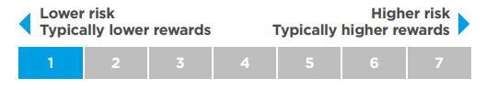

b, The Local Authorities’ Property Fund –
The Local Authorities’ Property Fund | CCLA
download (ccla.co.uk)
Key Information Document (ccla.co.uk)

(Redemptions are currently subject to a minimum notice period of 6 months). Gross Dividend yield 4.94% Dividend payment dates last day of January, April, July, and October. Minimum investment £25,000
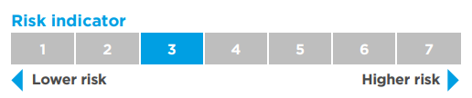

NB TAX
‘UK tax legislation may have an impact on your tax position. For further details you should consult your professional tax adviser.’ raised with Rialtas on Monday 08/04/2024

c, Nationwide/Virgin Money are negotiating a merger – suggested by (June 24). Nationwide would then have banking capacity.

Our Business Savings accounts
Business Savings accounts table
Account type | Account name | Interest rate
Instant access | Instant Saver* | Earn up to 2.25% AER/gross p.a. (variable)
35 Day Saver | Notice | Earn up to 3.35% AER/gross p.a. (variable)
1 Year Saver | Fixed | 4.25% AER/gross p.a. (fixed)

*For Instant access or Notice accounts: You can choose to have your interest paid monthly or annually. Interest is calculated daily. If your balance falls below £5,000 you will not earn interest until your balance returns to £5,000 or more.

d, Monmouthshire Building Society have been recommended however they are not currently opening new business accounts.

2

*1 Proposal re investment opportunities: that we offer Lee Jaggers several dates for a stand-alone meeting – so that a decision this important to ATC, would not be restricted by a 15 minute presentation.
*2 Proposal re change of banking is to wait to see if opening accounts with Nationwide would benefit the ATC. (Nationwide promise not to close branches until review in 2028. We have a branch here in town). We have waited this long another few months may not be critical.

