|  |  |
| --- | --- |
| **DATED 15th May 2024** |  |

**ABERGAVENNY TOWN COUNCIL**

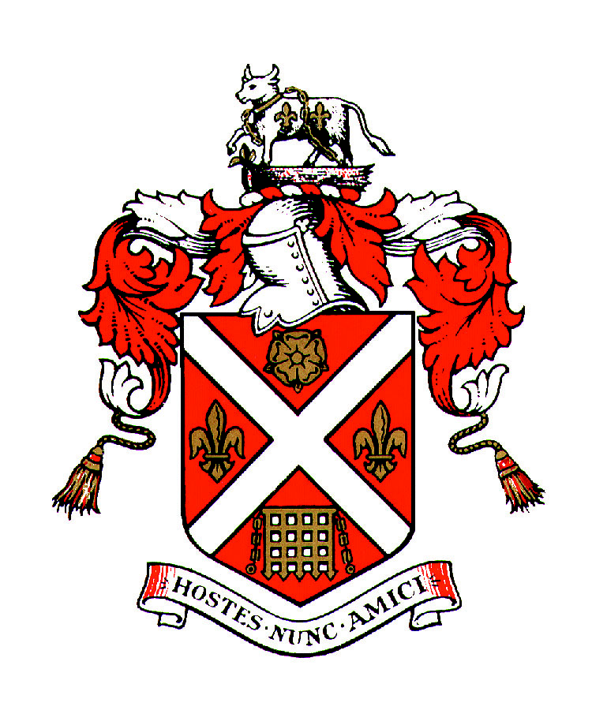

**and**

ABERGAVENNY ARTS FESTIVAL

_________________________________

**COOPERATION AGREEMENT**

for the provision of funding for

ANNUAL FREE COMMUNITY ARTS FESTIVAL

_________________________________

**AGREEMENT**

**DATED: 15th May 2024**

**BETWEEN:**

1. **ABERGAVENNY TOWN COUNCIL** of Town Hall, Cross Street, Abergavenny (the **“Council**”).
2. ABERGAVENNY ARTS FESTIVAL (AAF)

**COOPERATION AIMS**

1. Abergavenny Town Council has statutory duties under the Well Being of Future Generations Act and has identified a number of organisations that can help the Town Council fulfil their duties. Abergavenny Arts Festival is one such organisation.
2. Abergavenny Arts Festival can help the Council address the identified priority areas which are protecting and enhancing the natural environment.   
   Abergavenny Arts Festival encourages eco-friendly practices, sustainability and practices that demonstrate awareness of environmental issues. Workshops will include activities that focus on looking after the natural environment. We aim to serve as a platform for local artists and makers to create community works with the visitors, to highlight the environmental projects run by various groups in town, who are also invited to the festival.
3. Abergavenny Town Council support Abergavenny Arts Festival in its aims to provide ongoing and voluntary improvements in widening accessibility to the arts for all the community.
4. Abergavenny Arts Festival seeks security of funding to enable the group to have a sustainable future and to create increased capacity to develop the biodiversity development, including the new fringe festival (which invited the whole town to become involved with the window art trail and arranging their own related activities). The financial support would enhance programming, attract more diverse artists, and foster community engagement, which will contribute to the Festival’s long-term success and ecological impact.

# COOPERATION SERVICES

## During the Term of this Agreement, the Council shall provide capital and revenue funding to support the work of Abergavenny Arts Festival as set out in Annex 1.

## Abergavenny Arts Festival will take appropriate steps to ensure value for money when letting contracts and that appropriate management arrangements are put in place to ensure that the quality of work is to a specified standard.

## The agreement is to incorporate:

### Capital and revenue funding to undertake the projects outlined in Appendix 1.

### In the event that any of these projects cannot be undertaken the Council will consider favourably allowing Abergavenny Arts Festival to use such funds for other, approved, projects in line with the cooperation aims outlined above.

# DELIVERABLES

## Abergavenny Arts Festival will deliver against the Wellbeing of Future Generations Act and the Town Council Strategy & Action Plan to implement changes to enhance biodiversity which works towards Section 6 of the Environment Act. Details of deliverables are set out in Annex 2.

# TERM AND TERMINATION & INDEMNITIES

## Subject to earlier termination in accordance with its terms, this Agreement shall commence on the 1st June 2024 and shall continue until 30th June 2026.

## This agreement may be terminated at any time by either party giving at least 12 months' clear written notice to the other party.

## There will be a review point every 12 months during the term of this agreement.

## Abergavenny Arts Festival should notify the Council at the earliest opportunity should the Group be considering closing down the project or that the project is in financial difficulty. This would enable the Council to consider its options regarding future funding.

## Abergavenny Arts Festival has in place appropriate insurances which includes public liability insurance. The group has sole responsibility for dealing with any claims from accidents or other events resulting in loss or injury even if the activity was partially funded using Council funding.

# PAYMENT

## The Council will pay £3000 in June 2024 following the signing of the agreement.

## Thereafter the Council will pay £3000 annually; the instalment will be paid prior to the Festival, which takes place in June each year. Future year payments would be subject to satisfactory annual review.

# VARIATION TO THE AGREEMENT

## Should either party wish to discuss a significant variation to the agreement, representatives shall meet to agree such variations. Significant variations will be added to this Agreement as supplementary appendices.

# PERFORMANCE MANAGEMENT

## As a minimum, the Council and Abergavenny Arts Festival will meet annually. This will involve a visit to the town hall to receive a presentation from the group. The performance measures are set out in Annex 3.

## One week before the visit an update report will be sent to the Principal Officer for circulation. The annual report structured under the agreed objectives should capture what has worked well and also what hasn’t worked well. It is important for both parties to be open and transparent to aid greater understanding. This report will form the basis for any changes to the deliverables for the coming year.

## During the year, copies of newsletters and reports should be circulated to the Principal Officer for circulation to all Councillors.

## **Cooperation Meetings**

## Both parties are able to request that a cooperation meeting is convened. This could be to discuss and explore potential issues or new proposals. Both parties are encouraged to view this as a meaningful partnership, with both parties wanting the same outcome.

# RESOLUTION OF DISPUTES

## If there is a dispute between the parties concerning any matter arising from or in connection with this Agreement, the parties will use reasonable endeavours to settle the matter in accordance with the dispute resolution procedure set out below.

## Any dispute which has not been resolved between the Nominated Representatives (to be nominated by the Town Council at the May Council meeting) within fourteen (14) days of the matter being raised, may be escalated by either party to the Chair of the Abergavenny Arts Festival and Full Council Committee by notice in writing.

# PUBLICITY

## Abergavenny Arts Festival will acknowledge the support of the Town Council whenever possible on their website, social media, printed materials etc.

|  |  |
| --- | --- |
| Signed on behalf of Abergavenny Town Council  ***By:*** | ) **Signature**:  ) **Date:** |

**Position at Abergavenny Town Council:**

|  |  |
| --- | --- |
| Signed on behalf of Abergavenny Arts Festival  ***By:*** EMMA KATE BEVAN-HENDERSON  ***Position held at Abergavenny Arts Festival:*** | ) **Signature**:  ) **Date**: |

**ANNEX 1**

**COOPERATION FUNDING- PROJECT PLANS**

Our project plans encompass diverse artistic events, including performances (both music and dance), workshops, exhibits, talks, art trail and a crafts market.

With a focus on local talent and community engagements, the festival aims to celebrate creativity, foster connections, and enrich cultural experiences for residents and visitors alike.

**ANNEX 2**

**DELIVERABLES:**

Our deliverables include:

● Diverse performances, workshops and exhibitions

● Town-wide window art trail (from 1st to 15th June)

● Engaging the wider community via cultural and creative activities

● To foster collaboration and appreciation for the arts

● Promote local talent

● Enrich the creative and cultural fabric of the town and the county

**THE WELL-BEING OF FUTURE GENERATIONS ACT (WALES) 2015.**

How this is reflected in the existing provision and ongoing projects and how this benefits the people of Abergavenny and visitors now and in the future Community arts festivals such as ours foster social cohesion, cultural appreciation, and environmental consciousness.

By promoting inclusivity, creativity and sustainable practices, it enhances community well-being, supports local economies, and safeguards cultural heritage for future generations.

**A PROSPEROUS WALES**

Abergavenny hosts several festivals and this has made a significant impact on the town, drawing in tourists from all over the country. The Abergavenny Art Festival can add something to this. It has been running for several years, growing steadily despite the setbacks of the pandemic. The town has a portfolio of art and craft venues, which has grown in the past 12 months– all contributing to Abergavenny becoming known as a town of the arts, and of festivals. By providing this event, artists are paid but also given a platform to showcase and promote their talents, sell artworks and build their audiences for the future.

Towns and cities filled with art and art events add great value to the tourism industry, and an event like ours is no different. Whilst the event is free to enter, visitors spend money on refreshments in and around the venue, buy local products from the retail area on site and in the town and so is a great opportunity for vendors to raise their profile.

**A MORE RESILIENT WALES**

People will learn about art, artists and performers they had not heard of before and find out about opportunities to join new classes and events relating to the arts.

Being able to access the arts for free is a huge boost to the general well-being of all those that take part. Discovering makers , artists and performers is also beneficial to the local economy, as more visitors and residents become aware of what is available on their doorstep.

The event is largely an outdoor event in the inspiring setting of Abergavenny Castle, nestled in the foothills of the Brecon Beacons/ Bannau Brycheiniog. The festival invites people into this historic site to enjoy creative activities and entertainment whilst exploring the history and culture of this market town.

Most of the visitors, artists and performers will be from the region, here to engage in a festival atmosphere and promote themselves for future workshops and events they themselves attend or are available for.

**A HEALTHIER WALES**

Art is widely accepted as holding a central role in wellbeing. Increasing participation and interest in the arts can serve a community well, and the festival can be a highlight on the calendar of events that draw people into the town.

Volunteering can also be a wonderful experience, where people can make new friends and contribute to society through the generous donation of their time. Events like ours can’t run without the invaluable contribution of time through volunteers and is an indicator of wellbeing when people give back to their community through such activities.

There are many studies which highlight the tremendously beneficial impact participating in arts activities can bring to individuals and communities, promoting mental well-being, encouraging participation, and increasing confidence, as well as tackling isolation.

**A MORE EQUALWALES**

What can we say about diversity?

The festival is for everyone, regardless of age, ability, gender, or race. We welcome everyone equally and ensure the programme delivers content to suit all ages. The festival site is accessible for wheelchair users or anyone with mobility issues.

We have invited Abergavenny Pride to run a stall, as well as street food stalls embracing different cultures.

Our arts festival is all about involving all the community. We can help to foster diversity and equality by showcasing a range of cultural expressions, promoting inclusivity, offering accessible programming, and facilitating intercultural understanding amongst participants and attendees.

**A WALES OF COHESIVE COMMUNITIES**

The whole town has been invited to participate, either as attendees, entertainers, volunteers or as a local business running a complimentary activity such as hosting a window display or activity that can feature in the festival schedule.

The event is free to enter, so nobody is excluded, and makes available a range of arts and crafts workshops, shopping experiences, complemented by food and drinks stalls selling a range of snacks and food so that visitors can spend the whole day on site. There will be seating and break out areas for those simply wanting to soak up the atmosphere and people watch, or take a small break from engaging with activities. Attendees range from the solo traveller to broader family groups who have come for the whole day’s entertainment.

When planning for the festival, we use social media to cast the message widely that we are looking for participation from local businesses, artists, performers and musicians to try to give anyone a chance to put themselves forward if they are interested. We encourage people to volunteer on the day.

The committee is largely made up of women who are art and crafts practitioners, most of whom own their own creative businesses. They care deeply about this community event, volunteering their own time, creativity, network and resources to make it a success.

**A WALES OF VIBRANT CULTURE AND THRIVING WELSH LANGUAGE**

Visitors are invited to come and learn new art and craft skills, which they can continue to practice and develop further at home or school, for wellbeing and to develop their creative side. For school children just about to start their summer holidays, this can really be the start of a new creative direction for them. Many of the workshops will result in art and craft pieces that attendees can take home as keepsakes, to remember a wonderful day out in the heart of the community.

Most of our publicity materials and website will be available in Welsh, and translation is a central activity in the event plan.

**A GLOBALLY RESPONSIBLE WALES**

What can we say about environmental impact, recycling, low energy use?

The Abergavenny Arts Festival promotes the use of recycled or recyclable materials by both workshop practitioners and the food providers.

We wish to implement recycling stations around the castle grounds, and hope MCC can help with this too.

We encourage the use of eco-friendly materials wherever possible.

We have minimal use of electricity, we will promote the use of public transport and car-sharing where practical.

There will be educational activities and talks to encourage attendees toward more sustainable practices.

____________________________________________________________________

**SECTION 6– ENVIRONMENT (WALES) ACT 2016**

**Biodiversity and resilience of ecosystems duty**

Our community arts festival can promote the biodiversity and resilience of the Ecosystem by showcasing nature-inspired art, holding workshops and talks on sustainable practices and the concept of environmental stewardship.

Through interactive activities and talks, the visitors can learn about local ecosystems, and the importance of preserving biodiversity.

We are inviting Stump Up for Trees, the Abergavenny Orchard, and other local conservation groups to have a presence at the Festival, and provide talks, walks and discussions regarding their specific aims.

These Educational initiatives can highlight Wales’s rich natural heritage, and the need to protect it.

We hope that by having access to these workshops and talks, the visitors to the festival will feel encouraged to join groups locally, and feel more empowered to become stewards of their surroundings.

**ANNEX 3**

**PERFORMANCE MEASURES**

The annual report will include the following measurements:

Referring to each Annex and their headings, we will report on the aims and objectives of each, and how successful these were, or how we achieved them, and how we can look to improve upon them if necessary.