E06/25: ENVIRONMENT COMMITTEE FINANCE REPORT UP TO 31.12.2024

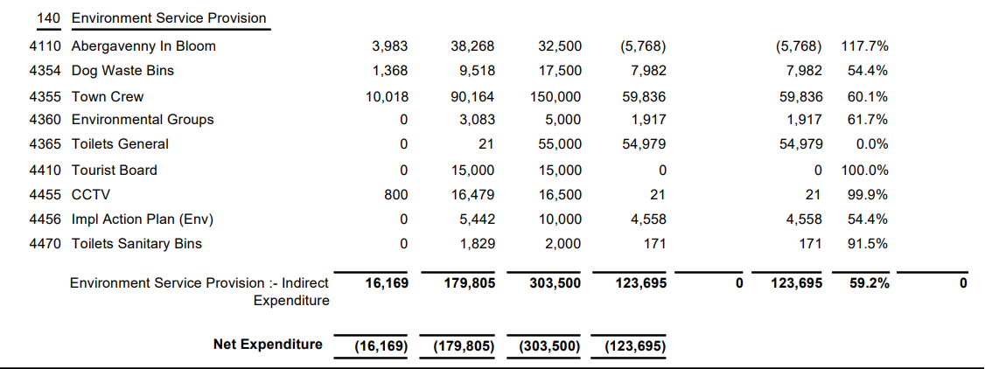

SIGNED AND CONFIRMED AS A TRUE RECORD AS PER AGENDA ITEM E06/25.

CHAIR……………………………………………………… DATE ……………………………………………………...

