E20/25: ENVIRONMENT COMMITTEE FINANCE REPORT UP TO 31.01.2025

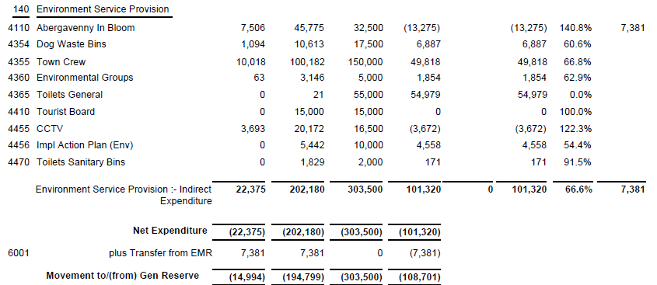

SIGNED AND CONFIRMED AS A TRUE RECORD AS PER AGENDA ITEM E20/25.

CHAIR……………………………………………………… DATE ……………………………………………………...

