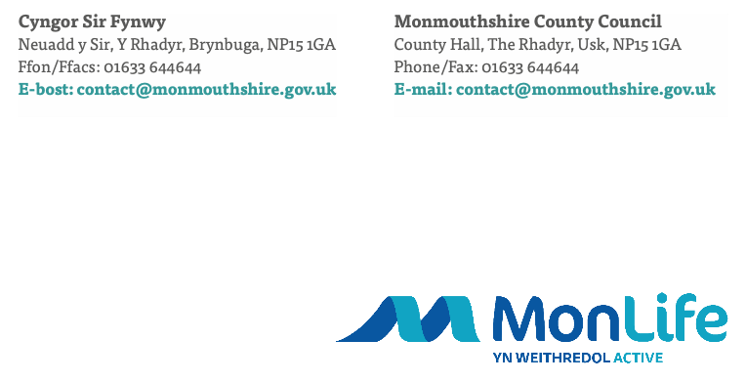

Dear Councilors,

As many of you will be aware the opportunity for our children and young people to engage in enriching and enjoyable Play activities form an essential part of their development. Whether it is through more structured sessions or through freely chosen play, these early experiences form an integral part of physical and social skills in readiness for transition into adulthood.

With thanks to your generous contributions to children and young people in the financial year 24/25 we have been able to provide a variety of provision to the children, young people and families of the town.

As stated in our service level agreement We are pleased to present to you information detailing a fantastic summer 2023 program which has had a significant impact on children and young people right across Monmouthshire. The impact has been captured in a series of formats including a detailed report, infographic, and impact videos. These are Monmouthshire wide and individual infographics and videos for each Town Council. The reports provide information on project delivery across MonLife, Monmouthshire County Council and partner organisations. Please feel free to share this across your networks as you wish.

The delivery of such a diverse range of activities would simply not be possible without the ongoing support of key partners, including Town and Community Councils, that we receive. The team remain extremely grateful for this and, as the report demonstrates, it is playing a vital part for families in response to the ongoing cost of living crisis. We would welcome conversations with regards to budgets for 25/26 to ensure this financial commitment remains and we can collaboratively discuss ways in which a localised offer can be developed to meet countywide objectives.

Thank you for your continued support.

Yours Sincerely,

MonLife Play and Youth Team

Email: play@monmouthshire.gov.uk

