PC07/25 (a): PEOPLE AND COMMUNITIES COMMITTEE FINANCE REPORT UP TO 31.10.2024

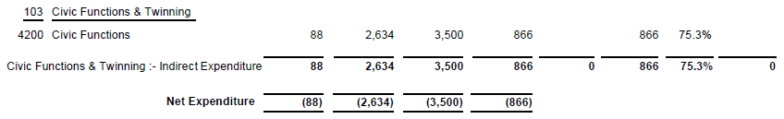
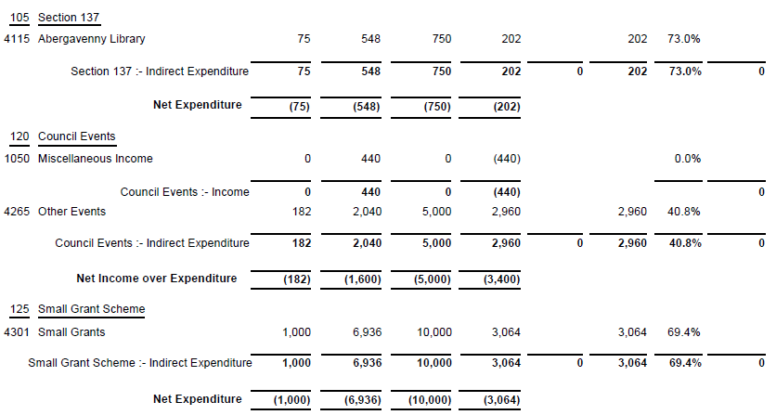

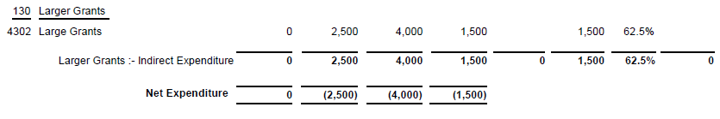

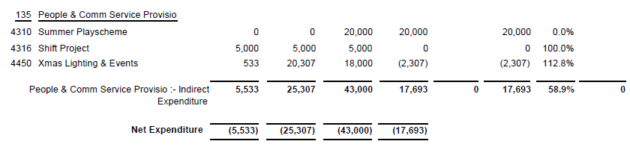

SIGNED AND CONFIRMED AS A TRUE RECORD AS PER AGENDA ITEM PC07/25(a).

CHAIR……………………………………………………… DATE ……………………………………………………...

