Deputy Principal Officer’s update
PC18/25
- High Sheriff’s Awards 19th February 2025 honouring:
Paul Cable, Helen Pickering, Peter Farthing, and our own Sandra Rosser. The event was filmed by the Media Agency.

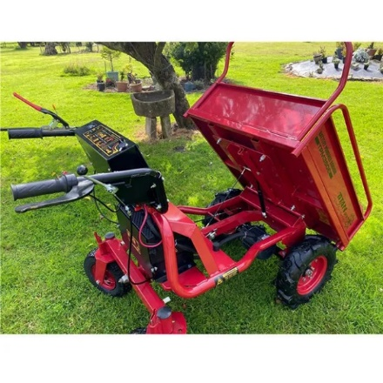
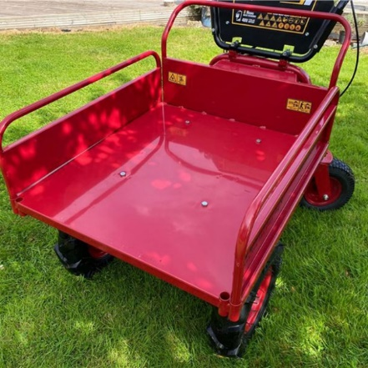
- ‘Doris – the Dumper’ has arrived and was in use today as the new planters were deployed in Frogmore Street. The opportunity is there for this electric vehicle to be used, by our contractors to move water and soil around the town; our Town Team; ourselves moving equipment/cones/road signs/ around town for events; volunteer groups. To be considered having in place before releasing it to the above: a) insurance in place to cover public liability/damage to vehicle; b) training in operator control of vehicle – health and safety; c) register: signed for agreement accepting liability for loss or damage and ‘leave-as– you-found-it’ eg clean; locked securely away, on charge, keys returned.

(iii) Celebrations to follow format of DDay 2024. Preparations well underway. All Councillors are invited to the events throughout the day. Also shout-out for volunteers to help with preparation tasks from 8am. The Events Company used for the Christmas Lights Switch on will be setting up/ dismantling the staging this year. They are also taking on the ESAG and Risk Assessment relieving the Office staff of that huge administrative responsibility.
Format of DDay Celebration event used with the following timings + (our events). Thursday night market stalls.
07:30/08:00 set up - Ellis arranging staging
09:00 Proclamation in front of Town Hall
11:00 Laying the wreath at Cenotaph
(17:00 Start event in the Market Hall - Nathan music via PA then entertainment)
18:30 Bell ringers at St Mary's Church (Jay to arrange)
(21:00 Vets and Cadets Parade into the Market)
21:30 light the beacon. Crowd join in singing 'I vow to thee my country'
End of Celebration/Clear down
(iv) Pugh’s & The Garden Kitchen Concept Lower Cross Street with a potential to create between 20 and 30 jobs
Planning Update DM/2025/00163 Change of use from A1 Retail to Mixed A1 Retail/ A3 food and drinks units, provision of storage buildings, external seating and associated works. 7 - 9 Mill Street, Abergavenny. https://planningonline.monmouthshire.gov.uk/online-applications/applicationDetails.do?activeTab=documents&keyVal=SRGW4QKYHNO00
CADW have objected: “it will only be in exceptional circumstance that planning permission will be granted if development will result in an adverse impact on a scheduled monument”.

