PC19/25(a): PEOPLE AND COMMUNITIES COMMITTEE FINANCE REPORT UP TO 28.02.2025

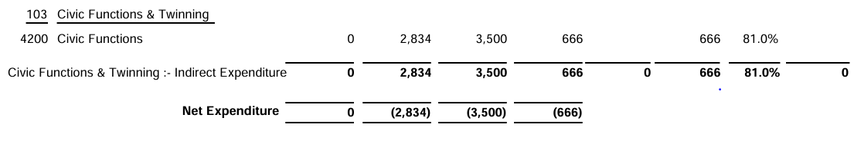
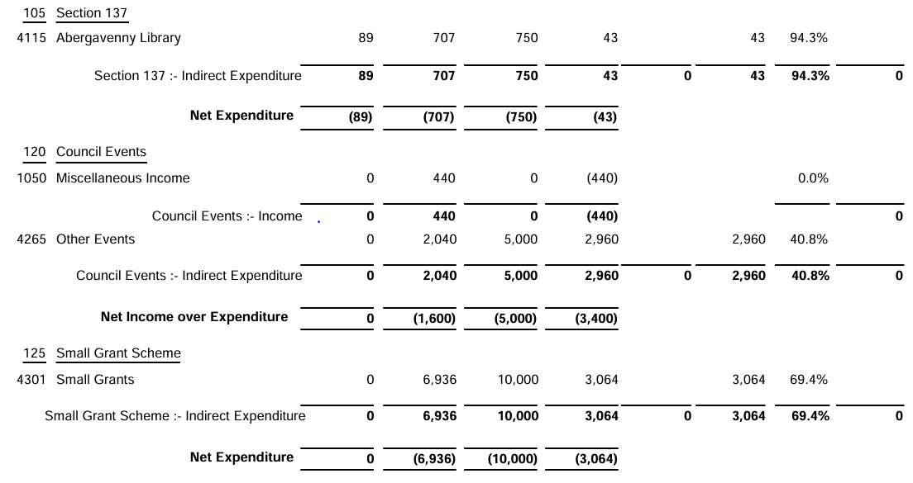

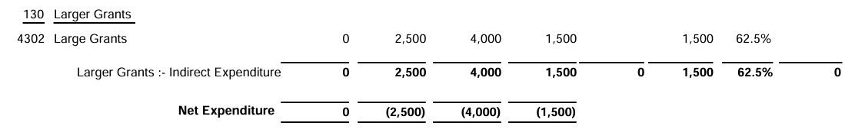

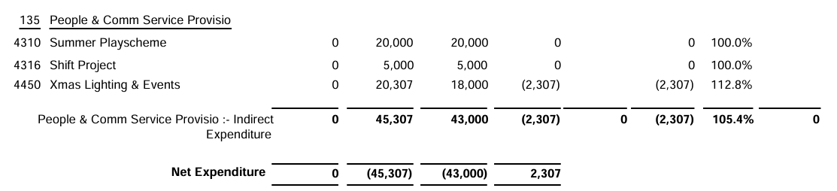

SIGNED AND CONFIRMED AS A TRUE RECORD AS PER AGENDA ITEM PC19/25(a).

CHAIR……………………………………………………… DATE ……………………………………………………...

