February 4th, 2025.
Dear Sandra,
I am writing in support of the Melville Centre’s application for £3K to help replace the Melville Centre’s Theatre Lighting system.
As a Lighting technician for 30 years I’ve come to appreciate the safety and convenience of modern LED Theatre lighting systems compared to traditional older and very hot Theatre lanterns. I’ve facilitated lighting design and rigging for many amateur and professional shows at the Melville in recent years and the resident system is archaic, time consuming and risky, bordering on dangerous.
The control desk is 30 years old and the lanterns date as far back as the early 1970’s. Changing lighting states and colours requires climbing ladders in very inappropriate places, overhanging seating in most cases. The current system requires changing colours and focussing whilst the lights are on and using 500 and 1000 watt bulbs, become extremely hot to touch as soon as they are on. Gloves are required to prevent burns. The old lanterns are also heavy to rig and move around, requiring strength and nerves of steel.
Modern LED systems, as detailed in the quotes, utilise remote control to change colour and focus and can be adjusted from the floor without negotiating heavy ladders, working at height and risking burns. LED lights also offer a wider range of colour and range available and decrease ongoing consumable costs with sensitive bulbs blowing and lighting gels that burn out – a common problem with older systems.
A wonderful benefit of a new LED system would be that we could start to initiate training for young people in stage lighting that we cannot do at present due to height and burn risk. These courses and sessions would increase the offer that Abergavenny can give to it’s local youth and provide greater accessibility to the arts and provide new career opportunities. A new system would also bring the Melville in line with 95% of other Theatres that have been modernised and also training at degree level in Drama and Technical colleges. As a professional Director and stage manager, I have seen that the Melville is lagging 30 years behind other small community Theatres throughout Wales.
I hope the above has been helpful. If you have any further questions, do please get in touch.
Yours sincerely,
Stuart H. Bawler, Director Melville CIC; Artistic Director, Hummadruz – Theatr Uwchfioled Cymru.
07870523345 ; info@hummadruz.co.uk

Li
Lighting Desk – Over 30 years old. Not up to modern requirements – modern desks can now be controlled through iPads and Phones.
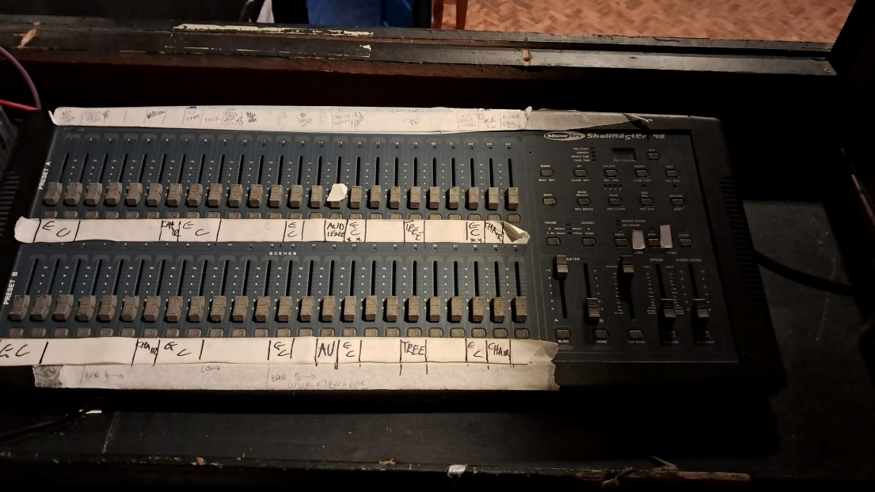

Control Boxes, in need of repair.
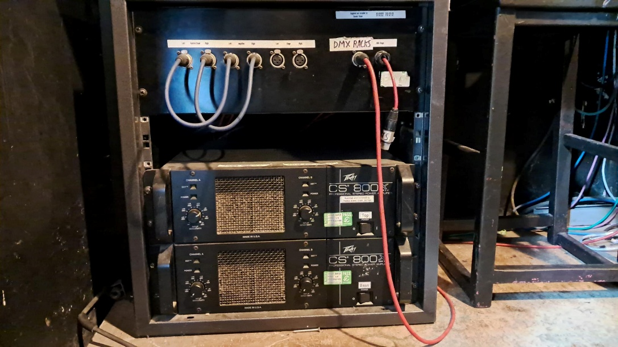

Lanterns in the auditorium – mixed, matched and acquired. Some date from the 1970’s. Accessible to change colour and focus from on top of a 5 metre ladder.
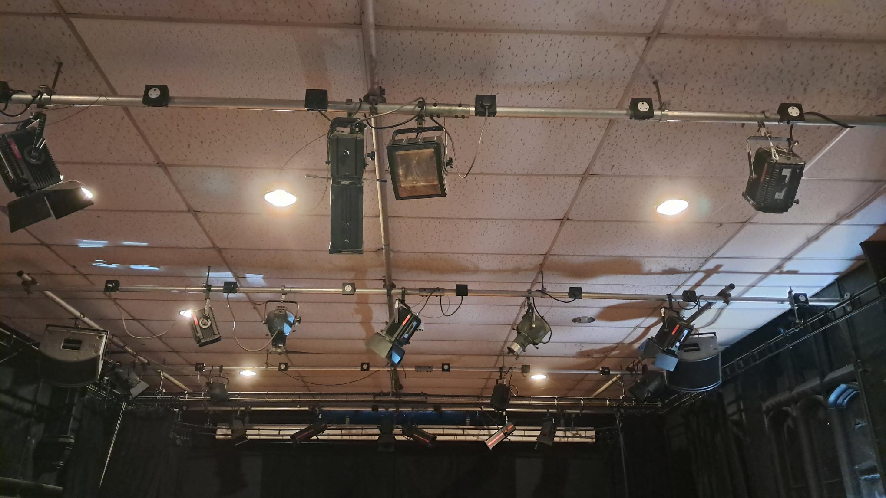
Lanterns over the seating which can only be adjusted by precarious ladder placement on the raked seating. Heavy and hot.
