E92/24: ENVIRONMENT COMMITTEE FINANCE REPORT UP TO 31.08.2024 – MONTH 5

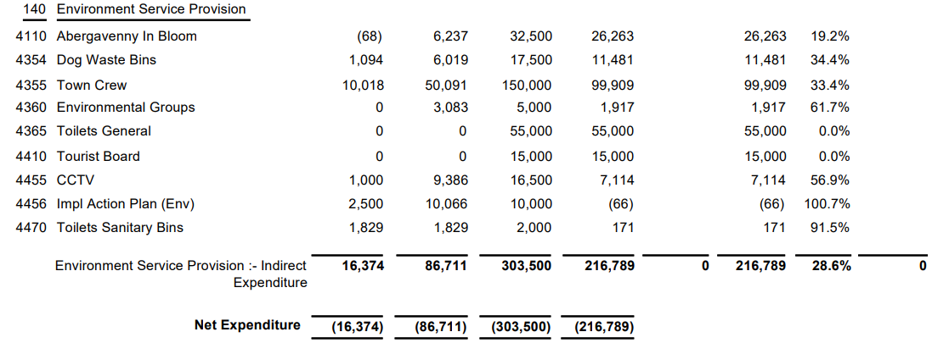

SIGNED AND CONFIRMED AS A TRUE RECORD AS PER AGENDA ITEM E92/24.

CHAIR……………………………………………………… DATE ……………………………………………………...

