E126/25: ENVIRONMENT COMMITTEE FINANCE REPORT UP TO 31.10.2025

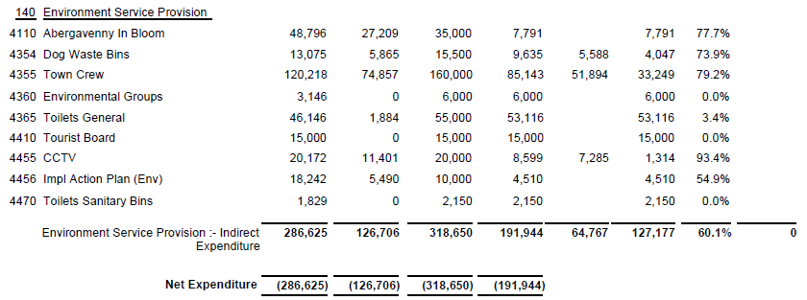

SIGNED AND CONFIRMED AS A TRUE RECORD AS PER AGENDA ITEM E126/25.

CHAIR……………………………………………………… DATE ……………………………………………………...

