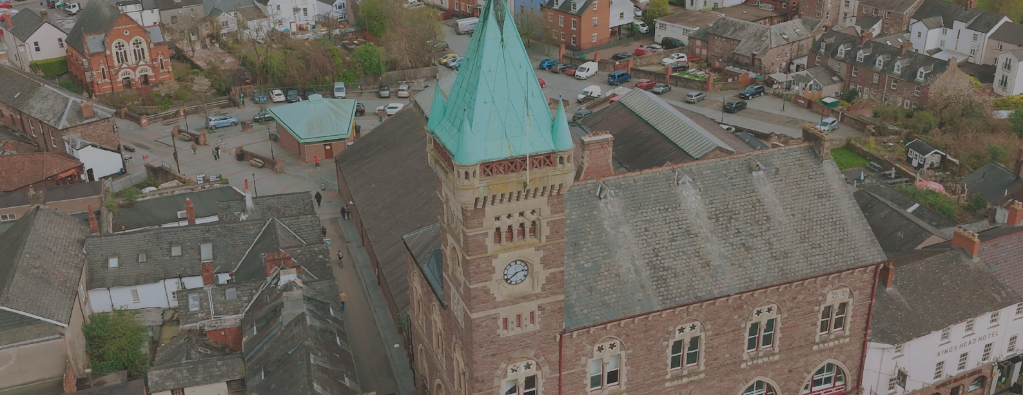

This application form is to be used to submit an application to Abergavenny Town Council Community Grant Scheme. Please read the guidance notes carefully before completing the form.

COMMUNITY GRANT SCHEME
APPLICATION FORM
Completed forms to be returned to clerk@abergavennytowncouncil.gov.uk or by post to Abergavenny Town Council, Town Hall, Cross Street, Abergavenny, NP7 5HD.

SECTION 1 - CONTACT INFORMATION

Group Name: Nevill Hall Nature Spaces CIO

Contact Name:
Pat Smail
Abergavenny
Postcode

Contact Address:

Contact Email: Position in Group:

Treasurer

YES
Contact Tel No:

Are you a constituted group holding annual AGMs?

SECTION 2 - TELL US ABOUT YOUR GROUP
Briefly tells us about the activities that your organisation/group undertakes
To support the restoration, development, and long-term care of the historic gardens and natural landscapes surrounding Nevill Hall Hospital in Abergavenny. for the benefits of patients, staff, visitors and the local community.
See attached document for further details.
1214695
No
Charity Number
Charity Details (if applicable)
VAT Registered?

What Well-being of Future Generations Act Deliverable/s would the grant contribute towards (please tick at least one of the below)
A prosperous Wales A resilient Wales
x
x
A healthier Wales
x
A more equal Wales
x
A Wales of more cohesive communities
x
A Wales of vibrant culture and thriving Welsh language A globally responsible Wales
x
x
Environment Act
x

SECTION 3 - TELL US ABOUT THE COMMUNITY PROJECT/ ACTIVITY YOU WANT TO UNDERTAKE
Please give more detail on how your project will meet the objective you selected above.
The Nevill Hall Nature Spaces project has been designed from the outset to align strongly with the principles and statutory duties of the Wellbeing of Future Generations (Wales) Act 2015 and the Environment (Wales) Act 2016. Both Acts require public bodies and partners to work in ways that safeguard natural resources, support resilience, improve community wellbeing, and ensure long-term sustainability. Our project directly advances these goals through ecological restoration, community involvement, improved access to nature, and the protection of the landscape for future generations.
See attached document for further details.

Total Project Cost:
£1220
£970
Yes

How much are you applying for:
Have you raised the balance of funds?
(25% of the total project costs are encouraged to come from alternative sources)

Please specify how you will use the Town Council grant?
The requested Town Council grant will provide essential start-up funding to enable Nevill Hall Nature Spaces to begin operational work, establish a visible community presence, and purchase the equipment and materials required for volunteer-led environmental restoration. As a new charity formed in 2025, initial financial support is crucial to ensure the project launches effectively and safely, with the structures in place to sustain activity throughout the first year.
Insurance £200
Stationery and Leaflet Printing £100
Website development £250
Gardening Tools £300
Additional Start Up resources £370
See attached document for full details.

How will your project benefit the community of Abergavenny?
The Nevill Hall Nature Spaces project will deliver substantial and wide-ranging benefits to the community of Abergavenny by transforming the hospital’s extensive grounds into a shared resource for wellbeing, recreation, biodiversity, artistic expression and civic engagement. These benefits will extend to patients, staff, visitors, local residents, schools, and community organisations.

See attached document for further details.

If your project involves working with young people please provide us with a copy of your safeguarding policy. This is required for anyone under the age of 25 years.




When will your project start and finish? Start Date:
January 2026
July 2027

Completion date:

Are there any outstanding permissions or agreements required before this project can start? If so, please list together with expected dates when these will be granted.
We are working in partnership with ABUHB and with their agreement and are currently working on a more formal MoU as this will be a long-term arrangement.

SECTION 4 - DECLARATION
If successful, please give details of the bank account the monies are to be paid into. Additionaly, please provide a copy of your group/organisation’s bank statement and group/organisation’s constitution.
Bank Account Details:

This application is to be signed by a person holding a position in the organisation applying for the grant. Before submitting the application please ensure that you have all the additional information as set out in the guidance.
Pat Smail
Nevill Hall Nature Spaces
3/12/2025
a
Signed:
On behalf of (name of group)
Date:

Town Hall, Cross Street, Abergavenny NP7 5HD 01873 353005
clerk@abergavennytowncouncil.gov.uk

