ABERGAVENNY TOWN COUNCIL
POLICY AND RESOURCES COMMITTEE
WEDNESDAY 10TH DECEMBER 2025
PR137/25 To receive a report on earmarked reserves
and future projects.

- PURPOSE
  - To consider the earmarked reserves and future projects.

- BACKGROUND
2.1 Current Earmarked reserves are as follows:
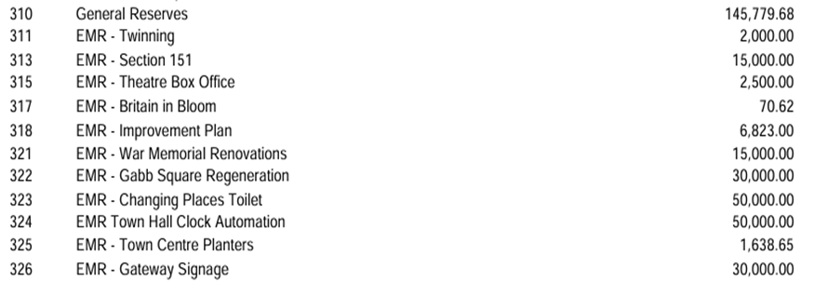

- PROPOSALS
  - To consider the proposal to refurbish the iconic 1871 Gillett and Bland the Town Hall Clock . A resident started a recent Facebook campaign raising public awareness regarding restoration of the chimes in the Town Hall Clock. This has generated considerable support from the public.
The Mayor/Chair of Policy and Resources Committee and officers of Abergavenny Town Council met with our Clock Restorer, The Media Agency, and the interested resident, to explore the appetite and feasibility of the project.
Permissions from MCC and CADW will be required, likely via the planning process.
Costs of the Restoration of the Town Hall Clock and all related works will be required in order to establish the level of additional funding required.
  - To consider the allocation of £50,000 into earmarked reserves allocated towards the White Horse Lane redevelopment, including demolition of the current structure and plans for future developments.
  - To consider allocation of £10,000 into earmarked reserves towards Public Art Projects, including graffiti art murals and public engagement projects.
  - To consider allocation of £10,000 into earmarked reserves for the consultation of signage and accessibility of the town centre to develop one of the priorities highlighted during the placemaking process.

- RECOMMENDATION
  - To recommend setting up the appropriate funding platform and related webpage to build on the Restoration of the Town Hall Clock Project, to include reinstatement of the chimes, automation of the mechanism, and refurbishment of the exterior tower and clock faces.
  - To recommend the allocation of funds for the White Horse Lane redevelopment.
  - To allocate funds towards the Public Art Project.
  - To recommend the allocation of funds towards the Signage and Accessibility Project.

