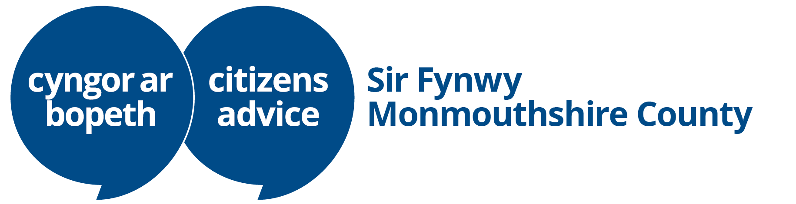

Dear Abergavenny Town Council

26th November 2025

I am writing to thank you for your past contributions to the running costs of Monmouthshire County Citizens Advice and to request your continued support, if possible, with an increased contribution to reflect rising costs..

In the 12 months leading up to September 2025, we assisted 501 unique clients, handling 693 cases from the wards that make up your council. We addressed nearly 2,000 issues, which helped increase their incomes by £476,177 over the year and write off £348,389 in problem debt.

Across Monmouthshire, we supported 2,830 people (the highest level in the ten years for which we have kept similar records), representing an average of 3.1% of the population. In Abergavenny, this percentage is higher. Residents from several of your wards are among the most likely in the county to seek our help, with 6% of the Grofield population and 5.7% of those in the Landsdown area utilising our services. Three of the council's six wards are above the 3% client/population average.

Our office in Cross Street, Abergavenny, is open for drop-in from 10 AM to 2 PM on Mondays, Tuesdays, Wednesdays, and Fridays, with specialist support appointments between 10 AM and 4 PM. This remains how clients prefer to get our support, but of course, it is the most costly approach for us. These drop-in sessions are complemented by telephone and email advice. We have recently added an AI-powered Self Help Tool to our website that will answer a range of welfare rights questions using a selection of trusted information sources. This is available year-round, day and night.

Most of our work involves assisting people with budgeting, entitlement to welfare benefits, helping with problem debt, helping people understand and respond to official letters, making complaints, seeking redress, and using the national and local expert support systems available.

The most common questions regarding benefits relate to disability, while the primary debt issues involve council tax and fuel debts. The transition from legacy benefits to Universal Credit currently accounts for a significant part of our caseload, historic overpayments being revealed and numerous DWP system errors, all of which can have devastating consequences for households.

Our advice significantly improves the lives of people facing challenging and often overwhelming situations, helping them to regain their footing after setbacks often beyond their control. For more information, including case studies and impact reports, please visit our website at monca.org.uk.

From our local cases and those recorded nationally, it is evident that our clients are still significantly affected by the rising cost of living. We track a range of issues that show the effects of the rise in the ‘cost of living’. These increased sharply in 2022, peaked in the winter of 2023-24, and have remained just below that high point since, well above pre-pandemic levels, with no sign of abating. As a consequence, we have seen an increase in clients facing problem debt, rent, council tax and utility arrears due to months of ongoing household budget shortfalls. Unfortunately, there is little prospect of improvement in this situation in the foreseeable future. While we cannot address the underlying causes of these issues, we can help mitigate many of the most distressing and serious consequences for citizens. The most vulnerable remain those on low incomes, particularly the disabled, single parents and families with dependent children. People regularly tell us that they don't know what they would have done without our help.

To illustrate this, it is estimated that for every £1 invested in MonCA we generate the following:

- £4.12 in Fiscal Value (£1,192,770) in savings to government and public services;
- £32.84 in Public Value (£9,516,880) in wider economic and social benefits;
- £22.70 in Specific Outcomes for Individuals (£6,578,970) in financial value to the people we help.

Abergavenny Town Council's contribution is crucial to us. Funding for charities like ours is limited in Monmouthshire. Over the last five years, 28% inflation has diminished the value of grants from our various funding sources; most have not increased at all during this period. In the past two years, Monmouthshire County Citizens Advice has used its reserves to partially fund the services that we provide to our communities, but this is no longer a sustainable option. We work hard to access additional funding from charitable sources, with some success, but this is not enough to close the gap.

We ask all our supporters to recognise the value we bring to residents and to consider increasing their grant funding.

If you would like more specific information regarding the wards in your area or if you would like us to speak to your council or group, please contact sue.prescott@monca.org.uk to make arrangements.

The first chart below displays the dashboard for the wards covered by Abergavenny Town Council for the 12 months ending in September 2025. Please note that the values for the Llanwenarth Citra ward are represented in our data under the old ward of Llanfoist & Govilon. While this is an approximation of the ward’s boundaries, it should not significantly distort the overall message conveyed by our numbers.

The second chart presents the number of clients from each ward in Monmouthshire, along with the percentage of each ward's population. This neutralises the effects of varying ward populations and provides a clear representation of where our clients are experiencing difficulties. This chart shows the Abergavenny Town Council wards highlighted in green.

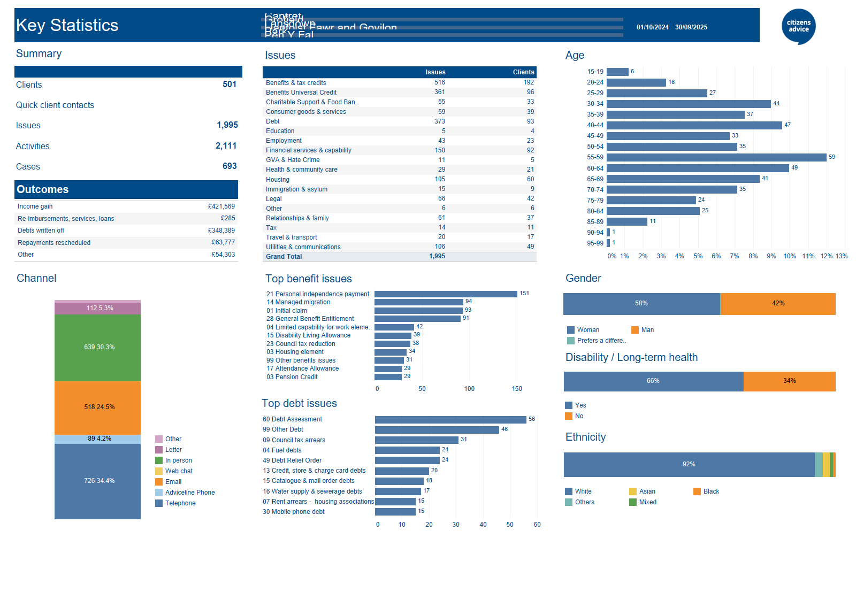
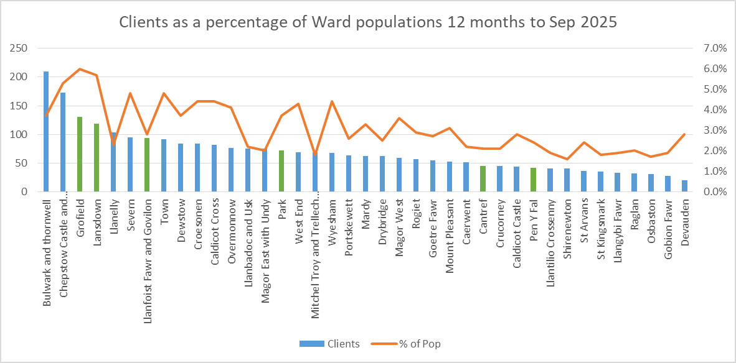

In conclusion, over the past ten years our contributions to the wellbeing of the community that we serve, most especially in Abergavenny,. has been considerable, notwithstanding the diminishing real-value of a large portion of our income, but at a point that the demand for our assistance is at its greatest we are now struggling to maintain anything like the level of service that is called for. In order to avoid further retrenchment I hope that Abergavenny Town Council will find it possible to maintain an appropriate contribution to the costs of our service.

Kind regards

Steve Read
Chair of the Board of Trustees / Cadeirydd Bwrdd yr Ymddiriedolwyr.
Monmouthshire County Citizens Advice / Cyngor ar Bopeth Sir Fynwy
Company Limited by Guarantee - Registered Number 6532431. Registered Charity Number - 1125068. Authorised and regulated by the Financial Conduct Authority FRN 617672.

