Dog poo hotspots
Sudbrook
Sudbrook cricket club pitches (Facebook 28 Nov 2015)
Sudbrook to Black Rock path
Sudbrook to Caldicot Pill cornfield
Sudbrook coast path west towards Caldicot.
Goytre (reported by Goytre Fawr school 3rd Dec)
Highfield Goytre, by the hairdressers, doctors surgery and electric little substation – reported by Mr Webb Goytre 23 July (dog bin has now been provided in this area)
Monmouthshire and Brecon Canal towpath Goytre
Midfield Goytre (Facebook 25 Nov)
Llanfoist
Woodland Crescent
The Cutting
Monmouth.
Wyesham green space near Newland Way, (dog bin has now been provided at Woodland View), also Tudor Rd
Vauxhall Meadows and Fields near Inglis Bridge etrance, and Cowlings Lane Monmouth (Feb 2016)
Cannes Farm Lane Mansons Cross
Maddox Close/Lancaster Way/ Beaufort Road Osbaston
Rockfield Road, near play park/football pitch
Williamsfield Lane off Wonastow Rd
Chippenham playing fields
Monnow Bank, just downstream of Old Monnow Bridge on Monmouth town side.
Carbonne estate green spaces.
Nailers Lane
Woodland View Wyesham
Justins Hill/Hillcrrest Wyesham
Community woodland Wyesham
alleyway between Church street and Priory Street
Osbaston Rd near Osbaston school
Verge opposite 10 Troy Way Overmonnow, bagged dog waste left on verge.
The Kymin National Trust property bowling green and gardens
Abergavenny
Mardy area of Abergavenny reported by Lauren MHA March 2016: St Davids Rd, St Andrews Crescent, St George’s Crescent, Llwynu Lane
Bailey Park Abergavenny
Castle Meadow Abergavenny. (202 piles of dog poo found and marked by Mark Langley and Deri View School April 2016, and didn’t even get to the exit)
Chapel Road, Stanhope Street, The Avenue, Park Road (sprayed template Jan 2017) (repeated dog fouling complaints 2024 especially bottom of Chapel Rd and Orchard Street).
Ffordd Llanfoist on new Llanfoist estate. (Sept 2017)
lane between Pen y pound and Chapel Rd, Abergavenny (4/7/18)
Summerfield Rd Abergavenny (KWT LEEMS report 2018)
Croesonen Gardens footpaths (signs needed)
Lower football pitches pen y pound
Derwen Way (Aug 2020)
Linda Vista Gardens
Alleyway between Ysguborwen and Park Crescent
Rother Avenue (around 63 Rother Ave) and generally on the pavements around the estate (Oct 2025)
Avenue Crescent Abergavenny
Commercial Street
Prince’s Street
Brecon Road
Frogmore Strreet
High St
Cross St
Railway station cut through to Holywell Crescent
Portskewett Community Councils hotspots updated June 2017)
Black Rock Picnic Site,
The Quest Play Park,
The Cornfield,
Sudbrook Road and Play Park,
Sunnycroft,
Main Road
outside ARW School.
Coastal path
Path under railway
Magor:
school field
3 fields car park on B4525
Top of Dancing Hill
Mill Common footpath between Dancing Hill and Pennyfarthing Lane
Blenheim Avenue footpaths
Kensington Park (summer 2016)
Quarry Rise, Meadow Rise, Briar close towards Mill Common (June 2017)
Meadow Rise to Pennyfarthing Lane
Vinegar Hill, Undy
Old Stone Road, Undy (off Vinegar Hill)
Undy Playing Fields, The Causeway, Undy
Tump Lane, Undy (off Vinegar Hill)
Footpath from end of Tump Lane Undy to Pennyfarthing Lane Undy (school)
Netherwent View and St Brides Road
Undy small green space at end of Oak Close.
Undy 4 Rockfield Rise NP26 3FG

Caldicot:
Oakley Way/Oakley Close Caldicot (template sprayed Dec 2016)
Firs Rd
Birbeck Rd (consistent complaints).
Astro turf pitch Caldicot bags being thrown over fence into pitches
Sandy lane complaint received from local resident Nov 2017
Comprehensive school playing fields
Cas troggi Park
Path from St Marys Church to Town Council offices
Caldicot Castle & Country Park – main footpath and other well used areas of the park.
Lane behind Caldicot railway station (Aug 2020)
Deepweir beyond houses towards playing field. (July 2022)
Dunlin Avenue area Caldicot. A footpath runs from Mill Lane,[ opposite Comp School main entrance] past the front of bungalows in Dunlin Ave, follow the public footpath to a small green area in front of you [ a dog waste bin is on that green]. (Aug 2022); signs
Walkways/footpaths, are then to Durand Primary School from turning left at the green AND also the next turning left which leads onto Alianore Road (Aug 2022); signs
Chaucer Close Caldicot, off Railway Rd, various green spaces
Goldfinch Close Caldicot (alleyway from Goldfinch Close to the bypass).
Longfellow Rd near Severn View social club
Behind Parc Rhudd/Clos Ystwyth is a green space by a pumping station. 50 piles of dog poo. Can we put up signs?
Outside 29 Cas Troggy Caldicot.
Moorland View and Pill Row Caldicot
Chepstow:
16 River View, Chepstow and as you go from his property turn right around the bend then on your right there is a hedge on a piece on council land, within this hedge there are 30/40 dog waste bags which have been thrown within - Please see photo. Please can this be looked into and for Mr Thomas to be contacted asap 07545557222
St Kingsmark Ave Chepstow (Facebook 25 Nov 2016)
Narrow footpath behind houses on Normandy Ave, between Normandy Ave and St Kingsmark Ave.
Coastal footpath from town to Warren Slade Wood July 2020
Footpath between Mathern Rd and Old Bulwark Rd July 2020
Tempest Drive, opposite the hospital – footpath behind houses and by large oak tree between Tempest Dr and Mounton Rd.
Thornwell outside the school and opposite the school up the hill.
Hollins Court: around the green spaces
Barnetts farm at the bottom end of the Bayfield estate. People throwing bagged dog waste in trees, bushes and onto his property.
Somerset Way flats to Thornwell Road Bulwark/Thornwell. (19/2/2025)
Mounton Drive, greenspace at the end w3w onion.reprints.valve
Itton
Drive from Home Farm to Howick Lodge.
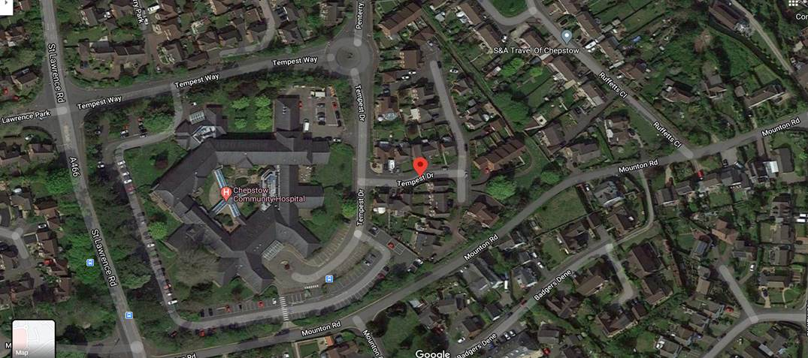
Maple Drive Bulwark
Pensioners Centre Bulwark
Welsh Street, bags of dog waste being thrown into garden of Ocean House 27a Welsh Street
Path from Mounton Rd garages to Old Bulwark Rd.
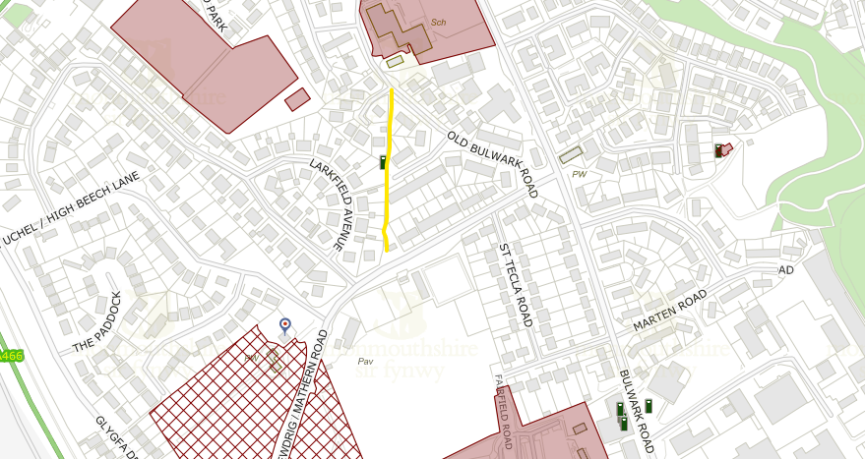
Alleyway between 19 and 21 Burnt Barn Road
Burnt Barn Road/Rowan Drive to Thornwell roundabout. Request for dog waste bin rejected by CTC, reported lack of litter bins in area and dog fouling on the pavement.
Gilwern
Monmouthshire and Brecon Canal towpath
Dan y Bryn
Footpath at Pen y Bont Terrace
Green space, Community Centre
Raglan
Path behind Raglan School
Usk
Path by Rural Life Museum
Path from Priory Gardens to St Marys Way (Pook Lane)
Riverside path from Athletic Club to Usk Bridge
Rogiet
Countryside Park,
Recreation area (reported again 2025)
Path outside school
Rugby pitch
Slade View approaching school
Caerwent
Path behind old peoples bungalows.
Lawrence Crescent
Grassy area along St Stephens Close
Playing fields at community centre, bagged dog waste thrown in hedge.
Ash Tree Lane
Roundbush Crescent

