E138/25: ENVIRONMENT COMMITTEE FINANCE REPORT UP TO 30.11.2025

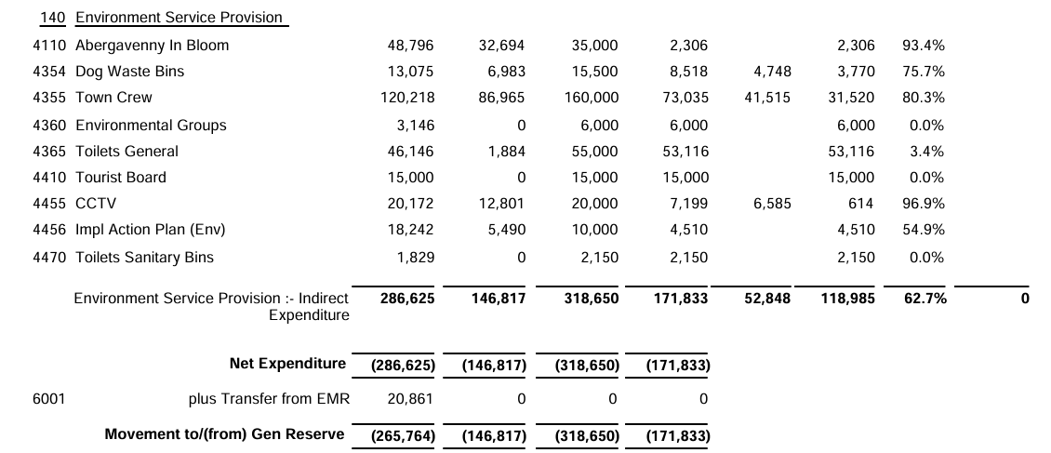

SIGNED AND CONFIRMED AS A TRUE RECORD AS PER AGENDA ITEM E138/25.

CHAIR……………………………………………………… DATE ……………………………………………………...

