Reference: CRXSS083/ Llanfoist to Abergavenny
Balfour Beatty
Merthyr Road
Llanfoist
Abergavenny
NP7 9LH
www.balfourbeatty.com

Active Travel Bridge and Links

4 June 2026
Upcoming works in Llanfoist, Abergavenny
Dear Resident,
We are writing to inform you about upcoming works in your area that may affect you. Our delivery partner, Balfour Beatty, will be commencing works on the Llanfoist to Abergavenny Active Travel Bridge and Links Scheme on 8/06/2026.
As part of the first phase of the project, residents may notice a range of activities taking place on site, including:
- Works compound set-up
- Works access road
- Construction of working platforms
- Piling - construction of foundations for landing and pier
- Caisson installation (in-river)
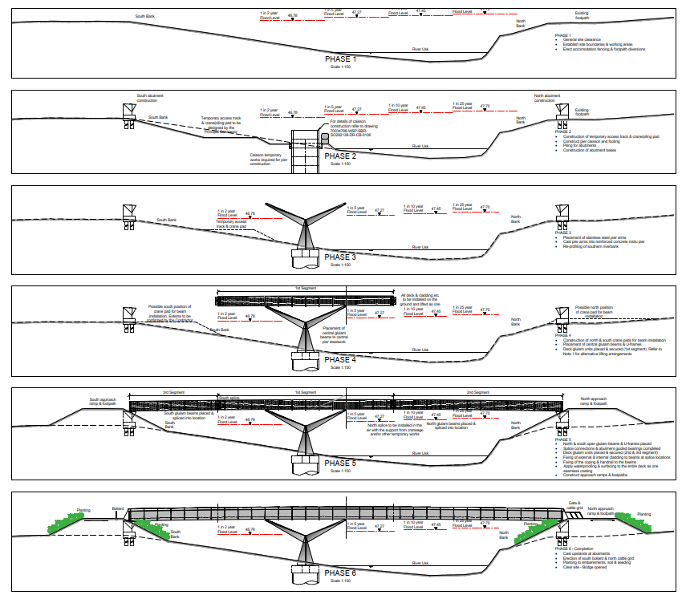
The Llanfoist to Abergavenny Active Travel Bridge and Links Scheme has been developed by Monmouthshire County Council and is funded by the Welsh Government through Transport for Wales and the Cardiff Capital Region. We appreciate your understanding while these essential preparatory works are carried out. We apologise for any inconvenience and should you have any queries or concerns, please email aats@balfourbeatty.com or phone 0800 121 4444.
Yours sincerely
Nicholas Tulp,
Head of Transport
Monmouthshire County Council

