ABERGAVENNY TOWN COUNCIL
ENVIRONMENT COMMITTEE
WEDNESDAY 24TH MAY 2026

E87/26: To receive a report on Abergavenny in Bloom.

1 Contractors’ Plantings
1.1 Majority of planters, baskets, boxes, lamppost baskets and barrier baskets installed. A40 new baskets to be installed shortly. A local business delighted with the change of planters.
1.2 Damage to plants in beehive planter. Police have arrested a person for the damage. Our contractor has agreed to replant ready for the judges’ visit (6,7,8th July).
1.3 The town containers and car park plantings are receiving attention. Mostly light maintenance ready for 7th July, town judging.

2 Portfolio
2.1 Deputy Principal Officer is meeting with TMA on Monday 22nd June to finalise the portfolio. This year the portfolio will feature all of our IYN groups, as well as the town route.
2.2 Two IYN groups have felt obliged to withdraw this year.

3 Abergavenny in Bloom as a constituted group.
The IYN groups were surveyed and responses are below.

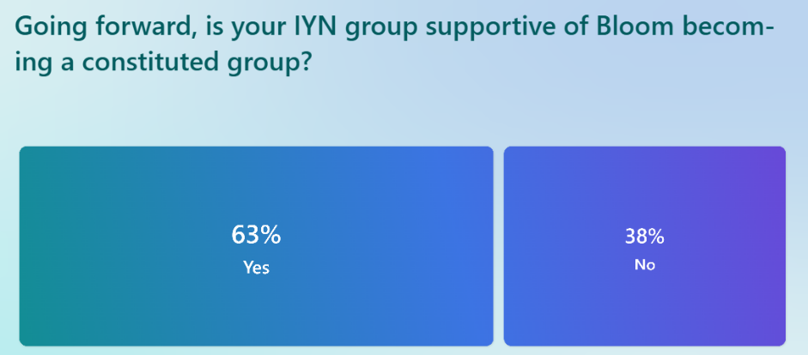

4 Recommendations:
4.1 That the Environment Committee approve the formation of ‘Abergavenny in Bloom’ (AiB) as a constituted group.
4.2 Going forward recommend that AiB consider applying for a co-operation agreement with Abergavenny Town Council.

